**College Search & Review Website**

BCAD681 Major Project

Major Project Submitted in Partial Fulfilment of the Requirements for the Degree of Bachelor of Computer Application

Submitted By

**31401221042 Sayan Mondal**

**31401221050 Sumit Sarkar**

Under the Guidance of

**Sarasij Majumdar**

**Assistant Professor, TICT**

**Department of BCA**



**TECHNO INDIA COLLEGE OF TECHNOLOGY, NEW TOWN**

**Block-DG 1/1, Action Area 1, New Town**

**Kolkata-700156**

**TECHNO INDIA COLLEGE OF TECHNOLOGY, NEW TOWN**

**Block-DG 1/1, Action Area 1, New Town Kolkata-700156**



CERTIFICATE OF ORIGINALITY

This is to certify that the project report entitled **College Search & Review Website** submitted to Bachelor of Computer Application, Techno International New Town, in partial fulfilment of the requirement for the award of the degree of BACHELOR OF COMPUTER APPLICATIONS (BCA) is an authentic and original work carried out by

**Roll Name**

31401221042 Sayan Mondal 31401221050 Sumit Sarkar

The matter embodied in this project is genuine work done by the student and has not been submitted whether to this University or to any other University / Institute for the fulfilment of the requirements of any course of study.

**Sayan Mondal**

**Sumit Sarkar**

**Sarasij Majumdar**

Assistant Professor, TICT

BCA Department

**TECHNO INDIA COLLEGE OF TECHNOLOGY, NEW TOWN**

**Block-DG 1/1, Action Area 1, New Town Kolkata-700156**



**Certificate of Approval**

The project **“College Search & Review Website”** is hereby approved as a creditable study of Bachelor of Computer Application (BCA) and presented in a manner satisfactory to warrant its acceptance as a prerequisite to the degree for which it has been submitted.

It is understood that by this approval the undersigned do not necessarily endorse or approve any statement made, opinion expressed or conclusion therein but approve this thesis only for the purpose for which it is submitted.

**Ammlan Ghosh**

Head, Dept. of BCA

Techno India college of Technology, New Town

**Date:**

**(External Examiners)**

**Date:**

**Date:** **Date:**

**INDEX**

|  |  |
| --- | --- |
| **Table of Contents** | **Page No.** |
| 1. Title of the Project | 6 |
| 2. Introduction and Objectives of the project | 7-8 |
| 3. Project Category | 9 |
| 4. System Analysis   |  |  | | --- | --- | | 4.1 | Identification of Need | | 4.2 | Preliminary Investigation | | 4.3 | Feasibility Study | | 10-13   |  | | --- | | 10 | | 11-13 | | 13 | |
| 5. Project Planning | 14-15 |
| 6. Project Scheduling | 16-19 |
| 7. Tools/Platform, Hardware and Software requirement Specifications | 20-21 |
| 8. Software Engineering Paradigm applied | 22-24 |
| 9. Requirement Analysis & Diagrams (UML, DFDs ER Diagrams etc.)   |  |  | | --- | --- | | 9.1 | ER Diagram | | 9.2 | Data Flow Diagram | | 9.3 | State Chart Diagram | | 9.4 | Activity Diagram | | 25-32   |  | | --- | | 25-26 | | 27-28 | | 29-30 | | 31-32 | |
| 10. System Design   |  |  | | --- | --- | | 10.1 | Modularization Details | | 10.2 | Data Integrity and Constraints | | 10.3 | Database Design | | 10.4 | Procedural Design/Object Oriented Design | | 10.5 | User Interface Design | | 10.6 | Test Cases | | 33-39   |  | | --- | | 33-34 | | 34 | | 34-36 | | 36-37 | | 37-38 | | 38-39 | |
| **Table of Contents** | **Page No.** |
| 11. Coding | 40-78 |
| 12. Testing   |  |  | | --- | --- | | 12.1 | Testing Techniques and Testing Strategies | | 12.2 | Testing Plan Used | | 12.3 | Test reports for Unit Test Cases and System Test Cases | | 12.4 | Debugging and Code improvement | | 79-82   |  | | --- | | 79-80 | | 80 | | 80-81 | | 81-82 | |
| 13. System Security Measures   |  |  | | --- | --- | | 13.1 | Security Measures | | 13.2 | Database/Data Security | | 83-84   |  | | --- | | 83 | | 83-84 | |
| 14. Process logic of Module (Flow Chart) | 85 |
| 15. Cost Estimation of the Project along with Cost Estimation Model | 86-87 |
| 16. Future Scope of Enhancement | 88 |
| 17. Conclusion | 89 |
| 18. Bibliography | 90 |
| 19. Glossary | 91-93 |

**TITLE OF THE PROJECT**

College Search & Review Website

1. **Introduction and Objectives of The Project:**
   1. **Introduction: --**

College is a pivotal chapter in our life—a time for growth, learning, and forging the path toward our dreams. Here at our College Search & Review website, “Unifind.in”, we understand the significance of this decision. That's why we've curated a platform that goes beyond mere listings. We're your companions in this quest for the ideal educational destination.

Our mission is simple: to empower you with information and resources that transform your search into a personalized, insightful experience. Dive into our user-friendly interface, where a world of possibilities awaits. From detailed insights into academic programs and campus life to invaluable advice on applications and scholarships, we're committed to being your guiding light in this exciting journey.

Whether you're envisioning a bustling urban campus or a serene rural setting, aiming for a specific major or exploring diverse fields, our comprehensive database and intuitive tools are here to cater to your unique preferences. Your aspirations are at the heart of what we do, driving us to provide a platform that's not just about finding a college but discovering the perfect fit—a place that feels like home, inspires growth, and nurtures your passions.

Join us on this exploration. Let's uncover the opportunities together and embark on a fulfilling academic journey that lays the foundation for a future filled with success and accomplishment.

* 1. **Objective: --**

There are some objectives of the proposed College Search & Review Website. Here we discuss about these objectives briefly------------

1. **Advanced Search Filters:** Users can filter colleges based on criteria like location, majors offered, admission deadlines, financial aid availability, campus facilities, and more.
2. **Personalized Profiles:** Students can create personalized profiles that store their academic and extracurricular achievements, standardized test scores, and other relevant information. The system will then suggest colleges that align with their qualifications and aspirations.
3. **Comprehensive College Profiles:** Detailed profiles for each college or university will include information on admission requirements, tuition fees, campus amenities, faculty qualifications, and alumni statistics.
4. **Reviews and Ratings:**  A feature allowing current and former students to leave reviews and ratings for colleges, providing valuable insights for prospective applicants.

This project aims to bridge the gap between students seeking higher education and the institutions offering it. By providing a comprehensive, user-friendly, and data-driven platform, the College Search & Review Website for Admission intends to empower students to make informed decisions about their academic futures while simplifying the college search and application process. This project aligns with the evolving needs of the education sector and leverages technology to make the college admission journey more accessible and efficient for students worldwide.

1. **Project Category:**

The project category of a college search & review website typically falls under the umbrella of "Education Technology" or "EdTech." This category encompasses digital platforms, tools, and applications that aim to enhance the educational experience through technology.

Specifically, a college search website would belong to the following categories within the EdTech sector----------

1. **Higher Education Tools:** Platforms designed to assist students in researching, exploring, and selecting colleges or universities for their higher education journey.
2. **Student Guidance and Counselling:** Offering resources, guidance, and counselling services to aid students in making informed decisions about their academic paths.
3. **Database and Search Platforms:** Platforms that compile extensive databases of educational institutions, enabling users to search, filter, compare, and access information about colleges and universities.
4. **Career and Academic Planning:** Providing tools and resources to help students plan their academic trajectory and align their studies with their career goals.
5. **Application and Admission Assistance:** Offering guidance on college applications, admission requirements, essays, scholarships, and financial aid.
6. **Community and Networking:** Platforms that foster communities among students, alumni, counsellors, and educational institutions, allowing them to share experiences, advice, and insights.

Categorizing the college search & review website within the context of Education Technology helps identify its role in leveraging technology to facilitate and streamline the process of exploring higher education options.

1. **System Analysis:**
   1. **Identification of Need: --**

In today's competitive academic landscape, students and parents face significant challenges when selecting the right college from an overwhelming number of options. A comprehensive and reliable college search and review website can address these challenges in the following ways:

1. **Information Overload:** Students often find it difficult to navigate the vast amount of information available about colleges and universities. They need a centralized platform that consolidates accurate and relevant data, such as course offerings, admission criteria, fees, and campus facilities, to make informed decisions without getting overwhelmed.
2. **Lack of Transparency:** Existing platforms may not always provide genuine reviews from current students and alumni, which can lead to misinformation. A trustworthy website that features authentic, verified reviews and ratings can offer prospective students a clearer and more accurate picture of what to expect from various institutions.
3. **Decision-Making:** The process of comparing different colleges based on multiple parameters can be complex and time-consuming. Tools that allow for easy comparison of institutions on aspects such as academic quality, campus life, career support, and extracurricular opportunities can significantly aid students and parents in making well-informed decisions.
4. **Personalized Recommendations:** Every student has unique academic interests, career goals, and personal preferences. Personalized guidance and recommendations based on individual profiles can help students find institutions that best match their specific needs, thereby enhancing their chances of academic success and personal satisfaction.
5. **User Experience:** An intuitive and user-friendly interface is crucial for making the college search process efficient and enjoyable. A well-designed platform that is easy to navigate, visually appealing, and responsive to user interactions can reduce the complexity of the search process and ensure a positive user experience.
   1. **Preliminary Investigation: --**

* **Objectives:**

The preliminary investigation aims to determine the scope and feasibility of developing the college search and review website. The key objectives include:

1. **Market Analysis:**

**Understanding Current Market Offerings:** Analyze existing college search and review platforms to identify what features and services they provide.

**Identifying Gaps:** Look for unmet needs or shortcomings in current offerings. This could include a lack of authentic reviews, poor user interface, limited search filters, or absence of personalized recommendations.

1. **User Requirements:**

**Gathering Requirements from Potential Users:** Conduct surveys and interviews with prospective students, parents, and educational consultants.

**Understanding Preferences and Pain Points:** Identify what users need in a college search platform, such as detailed college information, reliable reviews, comparison tools, and personalized guidance.

1. **Technical Feasibility:**

**Assessing Technical Requirements:** Determine the technical specifications needed to build and maintain the platform. This includes choosing the right technology stack, database management, and ensuring scalability.

**Identifying Potential Challenges:** Recognize challenges such as handling large volumes of data, ensuring real-time updates, and providing a seamless user experience.

1. **Economic Feasibility:**

**Estimating Costs:** Calculate the costs involved in developing, deploying, and maintaining the platform. This includes costs for software development, infrastructure, and human resources.

**Assessing Benefits:** Evaluate the potential benefits in terms of user satisfaction, market reach, and revenue generation.

**Cost-Benefit Analysis:** Compare the estimated costs with the expected benefits to determine if the project is financially viable.

1. **Operational Feasibility:**

**Evaluating Practicality:** Consider the real-world implementation of the platform, including user adoption, content management, and support mechanisms.

**Identifying Operational Challenges:** Address potential issues like ensuring data accuracy, moderating user-generated content, and providing ongoing technical support.

* **Findings:**

1. **Market Demand:** There is a high demand for a comprehensive platform that combines college search functionality with authentic reviews. Existing platforms often lack depth or reliability, highlighting an opportunity for a well-rounded solution.
2. **User Feedback:** Prospective students and parents emphasize the need for detailed and accurate information about colleges. They also value user reviews and tools that allow easy comparison of different institutions. Personalization is crucial, as each student has unique needs and preferences.
3. **Technical Requirements:** The platform should support:

* A large database to store extensive college information.
* Advanced search filters to help users find colleges based on specific criteria.
* User authentication for secure access and personalized experiences.
* Real-time updates to ensure information is current and relevant.

1. **Cost-Benefit Analysis:** Potential benefits include high user satisfaction due to the comprehensive and user-friendly nature of the platform. The broad market reach can lead to significant user engagement and retention. These benefits justify the initial and ongoing investment required for the project.
2. **Operational Challenges:** Ensuring data accuracy is critical for maintaining user trust and platform credibility. Effective management of user-generated content is necessary to prevent spam and ensure the quality of reviews. Providing consistent technical support will be essential for addressing user issues and maintaining a positive user experience.
   1. **Feasibility Study: --**
3. **Technical Feasibility:**

**Technology Stack:** Suitable technologies include React.js or Angular for the front-end, Node.js or Django for the back-end, and MySQL or MongoDB for the database.

**Scalability:** Use cloud services (e.g., AWS, Google Cloud) to ensure scalability and high availability.

**Data Management:** Implement efficient data management practices for handling large datasets and quick retrieval.

1. **Economic Feasibility:**

**Cost Estimation:** Estimate costs for development, testing, deployment, and maintenance.

**Revenue Streams:** Potential revenue from advertisements, premium subscriptions, and partnerships with educational institutions.

**Cost-Benefit Analysis:** Evaluate whether the benefits in terms of user satisfaction and market reach justify the costs.

1. **Operational Feasibility:**

**User Adoption:** Conduct user trials to ensure the platform meets user expectations.

**Content Management:** Develop processes for moderating user reviews and maintaining data integrity.

**Support and Maintenance:** Set up a support team to assist users and handle technical issues.

1. **Project Planning:**

Planning a college search and review website involves several crucial steps. Let’s break it down:

1. **Requirements Analysis:**

* Understand the purpose and goals of your website. Features like college search, user reviews, user profiles, and search filters.
* Identify user roles (students, recruiters, administrators) and their specific needs.
* Define the data you need to collect and display (college details, reviews, user profiles).
* Determine any third-party integrations (e.g., Google Maps for location-based search).

1. **System Design:**

* Choose the technology stack (frontend, backend, database).
* Design the database schema for colleges, reviews, users, and other entities.
* Plan the user interface (UI) for search, review submission, and user profiles.
* Consider scalability, security, and performance.

1. **Development:**

* Implement the frontend using HTML, CSS, and JavaScript (consider using a frontend framework like React or Angular).
* Develop the backend using a suitable framework (e.g., Spring Boot for Java).
* Create REST APIs for college search, review submission, and user management.
* Integrate with a database (MySQL, PostgreSQL, etc.) to store college and review data.

1. **Testing:**

* Test each component (unit testing) and ensure proper functionality.
* Conduct integration testing to verify interactions between frontend and backend.
* Perform system testing to validate end-to-end scenarios (searching colleges, submitting reviews).
* Address any bugs or issues.

1. **Deployment and Hosting:**

* Choose a hosting provider (e.g., AWS, Heroku, or a shared hosting service).
* Deploy your application to a server.
* Set up domain and SSL certificates for secure communication.

1. **User Experience (UX) Improvements:**

* Continuously gather feedback from users.
* Optimize the UI/UX based on user behavior.
* Consider accessibility and mobile responsiveness.

1. **Maintenance and Updates:**

* Regularly update content (college information, reviews).
* Monitor performance and security.
* Address any issues reported by users.

1. **Project Scheduling:**

A well-structured project schedule is crucial for the successful development and deployment of a college search and review website. Here’s a detailed project schedule, broken down into phases with key milestones and timelines.

**Project Phases and Milestones: ---**

1. **Project Initiation -----**

**Duration:** 1 weeks

**Key Activities:** Define project goals and scope, Assemble project team, Conduct initial meetings

**Milestones:** Project charter approval, Project requirements gathered

1. **Requirements Gathering and Analysis -----**

**Duration:** 2 weeks

**Key Activities:** Conduct surveys, Analyse user requirements and preferences, Define system requirements and features

**Milestones:** Requirements specification document

1. **System Design -----**

**Duration:** 4 weeks

**Key Activities:** Design system architecture, Create database schema, Design user interface wireframes

**Milestones:** System architecture document, Database design document, UI/UX design prototypes

1. **Development -----**

**Duration:** 8 weeks

**Key Activities:** Set up development environment, Front-end development (JavaScript, React JS), Back-end development (Spring-boot, Java), Database development (MySQL), Cloud development (AWS)

**Milestones:** Front-end module completion, Back-end module completion, Database integration

1. **Testing -----**

**Duration:** 2 weeks

**Key Activities:** Unit testing of individual components, Integration testing

**Milestones:** Completion of unit tests, Integration test report

1. **Deployment -----**

**Duration:** 1 weeks

**Key Activities:** Deploy the website to the live server, Conduct final testing and quality assurance

**Milestones:** Successful deployment, Live website launch

1. **Post-Deployment Support -----**

**Duration:** 1 weeks (Ongoing)

**Key Activities:** Monitor system performance, Bug fixes and updates

**Milestones:** Post-deployment support plan, User feedback analysis

* **Detailed Timeline: ---**

|  |  |  |  |
| --- | --- | --- | --- |
| **Phase** | **Duration** | **Start Date** | **End Date** |
| Project Initiation | 1 weeks | 01-Jan-2024 | 08-Jan-2024 |
| Requirements Gathering | 2 weeks | 09-Jan-2024 | 25-Jan-2024 |
| System Design | 4 weeks | 25-Jan-2024 | 20-Feb-2024 |
| Development | 8 weeks | 20-Feb-2024 | 18-Apr-2024 |
| Testing | 2 weeks | 18-Apr-2024 | 2-May-2024 |
| Deployment | 1 weeks | 3-May-2024 | 13-May-2024 |
| Post-Deployment Support | 1 weeks | 13-May-2024 | Ongoing |

**Pert Chart**

A PERT chart, Program Evaluation Review Technique, is a graphical representation of a project's timeline that shows the tasks needed to complete it. It's a project management tool that helps users map out a project's timeline and identify individual tasks.

PERT charts are used to identify a project's critical path, which is the longest task sequence, to estimate the project's duration. They're generally used before a project begins to plan and determine the duration of each task. PERT charts show whether tasks need to be completed in order or if they can be completed simultaneously.

**Pert Chart for College Search & Review Website**

Requirement Gathering

Project Planning

2

1

Start

2 Week

1 Week

Post-Deployment Support

System Design

Development

4

1 Week

4 Week

3

6

Deployment

8 Week

1 Week

2 Week

5

Post-Deployment Support

Testing

1 Week

7

Finish

**Gantt Chart**

A Gantt chart is a project management tool that illustrates work completed over a period of time in relation to the time planned for the work. It typically includes two sections: the left side outlines a list of tasks, while the right side has a timeline with schedule bars that visualize work.

Henry Gantt designed and popularized the Gantt chart between 1910 and 1915.

They are useful for planning and scheduling projects of all sizes, and can help project professionals monitor progress.

**Gantt Chart for College Search & Review Website**

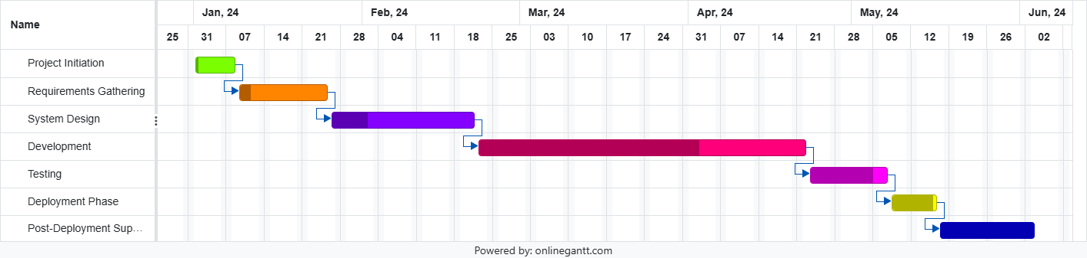

1. **Tools/Platform, Hardware and Software requirement Specifications:**
   1. **Tools/Platform: --**

The college search website is designed as a web-based application accessible across multiple platforms. It's optimized for compatibility with modern web browsers such as Google Chrome, Mozilla Firefox, Safari, and Microsoft Edge. The platform utilizes responsive design principles to ensure seamless functionality on various devices, including desktops, laptops, tablets, and smartphones.

* 1. **Hardware Requirement: --**

For optimal performance, users accessing the college search website are recommended to use devices with the following minimum specifications:

* **Desktop/Laptop:** Intel Core i3 processor or equivalent, 4GB RAM or higher, and a screen resolution of 1366x768 pixels or higher.
  1. **Software Requirement: --**

The website is developed using modern web technologies and requires the following software specifications for users:

**Frontend Software Requirements:**

* **React.js:** The frontend is developed using React.js, a JavaScript library for building user interfaces. React allows for the creation of interactive, component-based UIs, enhancing the user experience.
* **JavaScript (ES7+):** Utilizing modern JavaScript features to write the logic and functionalities of the frontend components in React.
* **CSS:** Incorporating CSS for styling, complementing React components to create visually appealing and responsive designs.
* **Frontend Libraries:** Leveraging additional frontend libraries or tools compatible with React, such as Redux for state management or Axios for handling HTTP requests.

**Backend Software Requirements:**

* **Spring Boot:** Implementing the backend using Spring Boot, a Java-based framework that simplifies the development of robust, production-ready web applications.
* **Java:** Utilizing Java programming language to write backend logic, handle business logic, and interact with the database.
* **Spring Framework:** Leveraging the Spring ecosystem components (such as Spring Data JPA for database access and Spring Security for authentication) within the Spring Boot framework.
* **RESTful APIs:** Creating RESTful APIs using Spring Boot to facilitate communication between the frontend and backend, enabling data exchange in JSON format.

**Database Management:**

* **MySQL:** Employing MySQL as the relational database management system to store and manage data related to colleges, user profiles, preferences, etc.

**Cloud Deployment:**

**• AWS:** Using Amazon Web Services (AWS) for the deployment of the project in the cloud server. Services used for the deployment are AWS S3 for static web hosting, AWS EC2 for creating instance to deploy the APIs and AWS RDS for virtual database connectivity.

These technologies working together ensure the creation of a robust, responsive, and secure college search & review website, with React.js handling the frontend, Spring Boot powering the backend, and MySQL managing the database operations.

1. **Software Engineering Paradigm applied:**

SDLC is a step by step procedure or systematic approach to develop software and it is followed within a software organization. It consists of various phases which describe how to design, develop, enhance and maintain particular software.

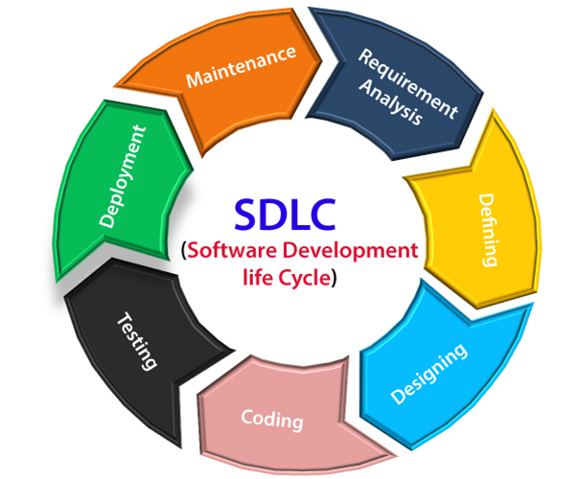

1. **Waterfall Model: ---**

The Waterfall Model is a linear and sequential approach to software development. It involves completing each phase before moving on to the next. This model is suitable for projects with well-defined requirements and where changes are expected to be minimal once the project starts.

**Application to College Search & Review Website -----**

* **Requirements Gathering:**  Detailed requirements can be gathered through surveys and interviews.
* **System Design:** Based on fixed requirements, the architecture, UI/UX, and database design can be done.
* **Development:** Front-end, back-end, and database development in a sequential manner.
* **Testing:** Extensive testing after development is complete.
* **Deployment:** Once testing is complete, deploy the system.
* **Maintenance:** Perform regular updates and bug fixes.

This model can be used if the requirements are clear and unlikely to change during the development process.

1. Agile Model: ---

The Agile Model is an iterative and incremental approach that emphasizes flexibility and customer collaboration. It involves developing the software in small, incremental releases with continuous feedback and adaptation.

**Application to College Search & Review Website -----**

* **Iteration Planning:** Break down the project into small, manageable iterations.
* **Requirement Gathering:** Continuous interaction with users to refine requirements.
* **Development:** Develop in iterations, focusing on core features first and adding enhancements later.
* **Testing:** Conduct testing in each iteration to ensure functionality and quality.
* **Deployment:** Regularly deploy increments to gather user feedback.
* **Feedback Loop:** Use feedback to refine and improve subsequent iterations.

This model is suitable if requirements are expected to evolve or if quick user feedback is essential.

1. **V-Model (Verification and Validation Model):**

The V-Model is an extension of the Waterfall Model, emphasizing verification and validation. Each development phase is associated with a corresponding testing phase.

**Application to College Search & Review Website -----**

**Requirements Gathering:** Define clear requirements with corresponding test plans.

* **System Design:** Design with a focus on testability.
* **Development:** Implement features with continuous validation.
* **Testing:** Parallel verification and validation for each phase.
* **Deployment:** Final validation before deployment.
* **Maintenance:** Ongoing verification and validation post-deployment.

This model is beneficial when the project needs thorough testing and quality assurance.

1. **Spiral Model: ---**

The Spiral Model combines iterative development with systematic aspects of the Waterfall Model. It focuses on risk assessment and reduction through repeated cycles (spirals).

**Application to College Search & Review Website -----**

* **Planning:** Identify objectives, alternatives, and constraints for each iteration.
* **Risk Analysis:** Assess risks and develop mitigation strategies.
* **Engineering:** Develop and verify the product in each spiral.
* **Evaluation:** Evaluate outcomes and plan the next iteration based on feedback.

This model is suitable if there are significant risks or uncertainties in the project.

1. **Requirement Analysis:**

Requirement analysis for a college search & review website involves various aspects, including capturing user interactions, functionalities, and system behavior. Unified Modeling Language (UML) diagrams can effectively represent these requirements. Here we provide some UML Diagrams (like ER Diagram, DFD Diagram, Activity Diagram etc.) ----------

* 1. **Entity-Relationship Diagram:**

` An Entity-Relationship (ER) diagram is a powerful visual representation used in database design to illustrate the relationships between different entities within a system. It's based on the Entity-Relationship Model, showcasing the entities (objects or concepts) in a database and the relationships between them.

The key components of an ER Diagram are Entities, Attributes, Relationships and Keys.

Entity Attribute

One to Many Relationship

Relationship Many to Many Relationship

M:N has

Category

1:M has

Course

1:M select

isCollegeUser

firstName

lastName

firstName

M:N search

User

College

isAdmin

lastName

1:M provide

M:N receive

Review

Entity-Relationship Diagram

* 1. **Data Flow Diagram:**

A Data Flow Diagram (DFD) is a visual representation that illustrates the flow of data within a system, showing how data moves between processes, entities, and data stores. It's a powerful tool used in system analysis and design to understand, describe, and organize the data flow within a system. The Data Flow Diagram reviews the current physical system, prepares input and output specification, specifies the implementation plan etc.

The key components of an ER Diagram are Entities, Processes, Data Flow and Keys.

Entity Process

Data Flow

* **Level 0 Data Flow Diagram:**

Database

User

Level 0 Data Flow Diagram

* **Level 1 Data Flow Diagram:**

Show College Details

User

Response

Accept/Reject Check College Details

College_Details

Request for

Registration

Check for

Registration

Response

User_Details

Accept/Reject Response

Request for Check for

Login Login

Response

Response

Accept/Reject

Check the College

Request for Apply College Details

College_Profile

Accept/Reject Response

Level 1 Data Flow Diagram

* 1. **State Chart Diagram:**

State Chart diagram is one of the five UML diagrams used to model the dynamic nature of a system. A State Chart Diagram, also known as a state machine diagram, models the dynamic behavior of an object in response to external stimuli.

For a college search and review website, a State Chart Diagram can illustrate the states and transitions involved in a user's interaction with the system.

State Chart diagram describes the flow of control from one state to another state. States are defined as a condition in which an object exists and it changes when some event is triggered. The most important purpose of State Chart diagram is to model lifetime of an object from creation to termination.



Actor

Lifeline

Message

--------------------------------

Reply Message

Self-Message

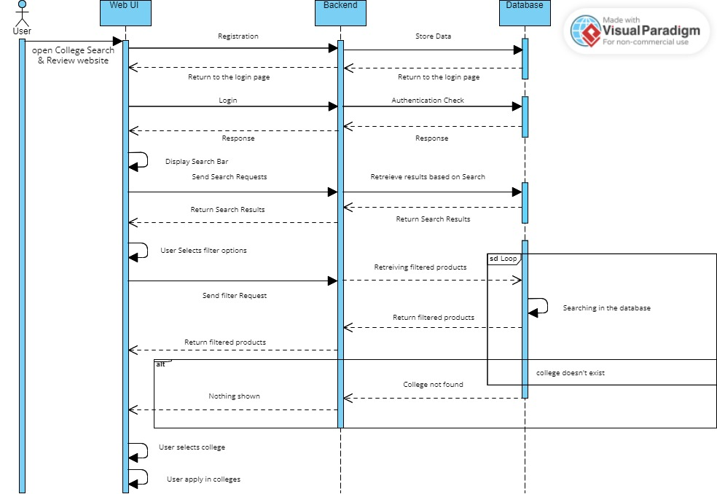

* 1. **Activity Diagram:**

An Activity Diagram is a graphical representation from the Unified Modelling Language (UML) used to visualize the workflow or sequence of activities within a system, business process, or software application. It displays the sequential flow of actions or steps, including decision points and parallel activities, showing how objects or entities interact within a system.

The key components of an ER Diagram are Actions, Initial, Final, Fork, Join, Merge, Decision and Control Flow.

Action Initial

Control Flow

Decision

Login to the Website

Start

Check the Login Information

Register in the Website

Successful Login in the Website

Search College

Show College Details

Apply College

Logout from the System

End

Activity Diagram

1. **System Design:**

The system design for a college search and review website encompasses various components and their interactions to provide users with a seamless experience in searching for colleges, reading reviews, submitting reviews, and comparing institutions.

The design includes modularization, data integrity measures, database design, user interface design, and test cases to ensure the system's robustness and usability.

* 1. **Modularization Details: ---**

Modularization involves breaking down the system into smaller, manageable modules that can be developed, tested, and maintained independently. For the college search and review website, the system can be modularized as follows:

1. **User Module -----**

**Functions:** Registration, Login, Profile Management, Logout.

**Components:** User Authentication, User Profile.

1. **College User Module -----**

**Functions:** Registration, Login, Profile Management, Logout, College Information.

**Components:** College User Authentication, College User Profile, College Profile.

1. **Search Module -----**

**Functions:** College search, Filter Criteria, Display Search Results.

**Components:** Search Engine, Search Filters, Display Results.

1. **College Details Module -----**

**Functions:** Display College Information, View Detailed Profiles.

**Components:** College profile, College Brochure, Admission Details.

1. **Review Module -----**

**Functions:** Submit Review, View Reviews.

**Components:** Review Submission Form, Review Display.

1. **Admin Module -----**

**Functions:** Manage College Data, Manage Student Data.

**Components:** Admin Dashboard, Data Management Tools.

* 1. **Data Integrity and Constraints: ---**

To ensure data integrity and constraints, the following measures are implemented:

**Unique Constraints -----**

* Ensure unique reviews for user accounts.
* Unique college & user IDs.

**Foreign Key Constraints -----**

* Link reviews to user IDs and college IDs.

**Validation Rules -----**

* Validate input data for Registration, Login, and Reviews.

**Data Consistency -----**

* Implement data validation at both client and server sides.
  1. **Database Design: --**
* **User:**

|  |  |
| --- | --- |
| Field | Data Type |
| id | Int |
| firstName | String |
| lastName | String |
| email | String |
| phone | Long |
| city | String |
| state | String |
| password | String |
| address | String |
| photofile | String |
| profilephotoUri | String |
| isAdmin | Boolean |
| isCollegeUser | Boolean |

* **College:**

|  |  |
| --- | --- |
| Field | Data Type |
| id | Int |
| name | String |
| firstName | String |
| lastName | String |
| phoneNumber | Long |
| email | String |
| address | String |
| affiliation | String |
| certification | String |
| city | String |
| state | String |
| establishmentYear | Long |
| filename | String |
| brochurefileUri | String |
| profilephoto | String |
| profilephotoUri | String |
| coverphoto | String |
| coverphotoUri | String |
| collegeweb | String |
| applyweb | String |
| rating | Double |

* **Course:**

|  |  |
| --- | --- |
| Field | Data Type |
| id | Int |
| course | String |

* **Category:**

|  |  |
| --- | --- |
| Field | Data Type |
| id | Int |
| category | String |

* **Review:**

|  |  |
| --- | --- |
| Field | Data Type |
| reviewid | Int |
| reviews | String |
| rating | Int |
| reviewDate | Date |

* 1. **Procedural Design/Object Oriented Design: --**

**Procedural Design -----**

1. **User/College User Registration Procedure:**

* User/College user input (username, email, password).
* Validate input.
* Validate Password.
* Insert user/college user data into the Users table.

1. **Submit Review Procedure:**

* Collect review input (reviewid, reviews, rating, reviewDate).
* Validate input.
* Insert review data into the Reviews table.

**Object-Oriented Design -----**

Classes and Methods:

User Class:

Methods: addUser(UserEntity user), getUser(), getUserByEmail(String email), getUserById(int id), deleteUser(int id), updateUser(int id, UserEntity updatedUser).

College Class:

Methods: getAllColleges(), getCollegesByState(String state), getCollegesByCity(String city), getCollegesByCityAndCourse(String city, String course), getCollegesByCourse(String course), getCollegeById(int collegeId), getCollegeWithCoursesById(int collegeId), saveCollege(CollegeEntity college), getCollegeByEmail(String email), updateCollege(int collegeId, CollegeEntity updatedCollege), deleteCollege(int collegeId).

Course Class:

Methods: getAllCourses(), getCourseById(int courseId), saveCourse(CourseEntity course), deleteCourse(int courseId).

Category Class:

Methods: getAllCategories(), getCategoryById(int id), getNumberOfCollegesByCategoryName(String categoryName), createCategory(CategoryEntity categoryEntity), updateCategory(int id, CategoryEntity categoryEntity), deleteCategory(int id).

Review Class:

Methods: addReview(ReviewsEntity review), getReviewsByCollegeId(int collegeId), getAverageRatingByCollegeId(int collegeId)

* 1. **User Interface Design: --**

**UI Components -----**

1. **Home Page:** Search bar, Featured Colleges Number, Courses Details.
2. **Search Results Page:** Filters, Search Results List, College Details.
3. **College Details Page:** College Information, Reviews section, Add Review Button.
4. **User/College User Profile Page:** User/College User Details, Edit Profile Options, Logout Button.
5. **Review Submission Page:** Review Form (Rating, Text), Submit Button.
6. **Admin Dashboard:** Manage Colleges, Manage Users, User Management.

**User Interface -----**

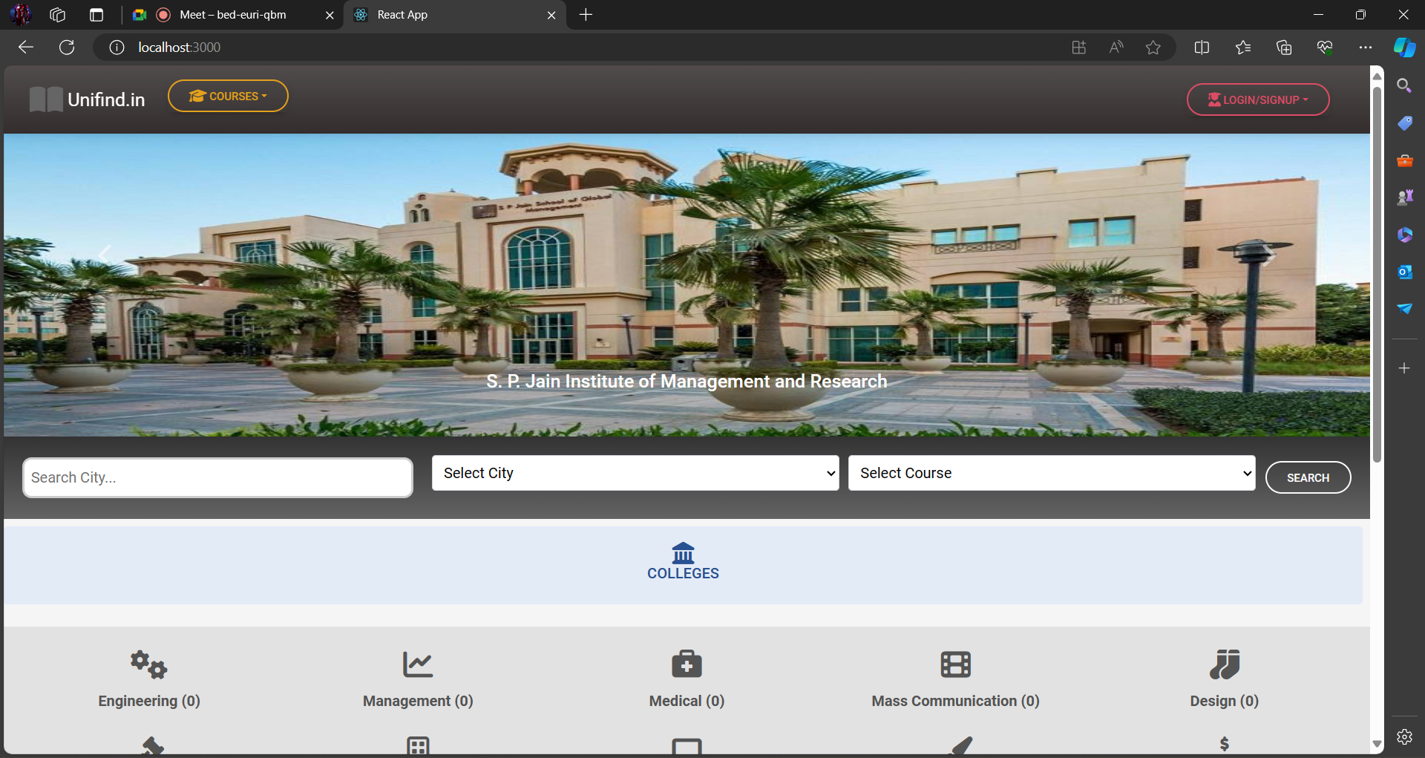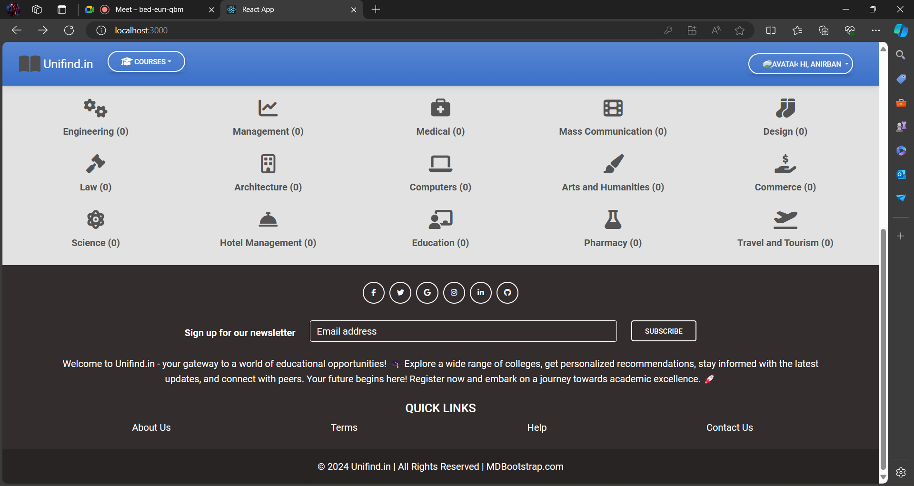

* 1. **Test Cases (Unit Test Cases and System Test Cases): --**

**Unit Test Cases -----**

1. **User Module:**

* Test user registration with valid/invalid data.
* Test user login with correct/incorrect credentials.

1. **Search Module:**

* Test search functionality with various criteria.
* Test filter application and result display.

1. **College Details Module:**

* Test display of college information.
* Test navigation to reviews section.

1. **Review Module:**

* Test review submission with valid/invalid data.
* Test review display for different colleges.

**System Test Cases -----**

1. **End-to-End Scenarios:**

* Test user registration, login, searching for colleges, viewing details, submitting a review, and logging out.
* Test the full comparison workflow: search, select colleges, download brochure and apply for colleges.

1. **Performance Testing:**

* Test system performance under load (multiple simultaneous users searching and submitting reviews).

1. **Security Testing:**

* Test user authentication and authorization.
* Test data validation and protection against SQL injection and XSS attacks.

1. **Usability Testing:**

* Test the user interface for ease of use and navigation.
* Gather feedback on user experience and interface design.

1. **Coding: --**

* **Home Page:**

The home page of a website is the first page that a user perceives upon entering the website URL at the browser address area. The entire website depends on how the home page is designed which forms the platform for viewing other web forms. In short, a home page forms the abstract of the entire project.

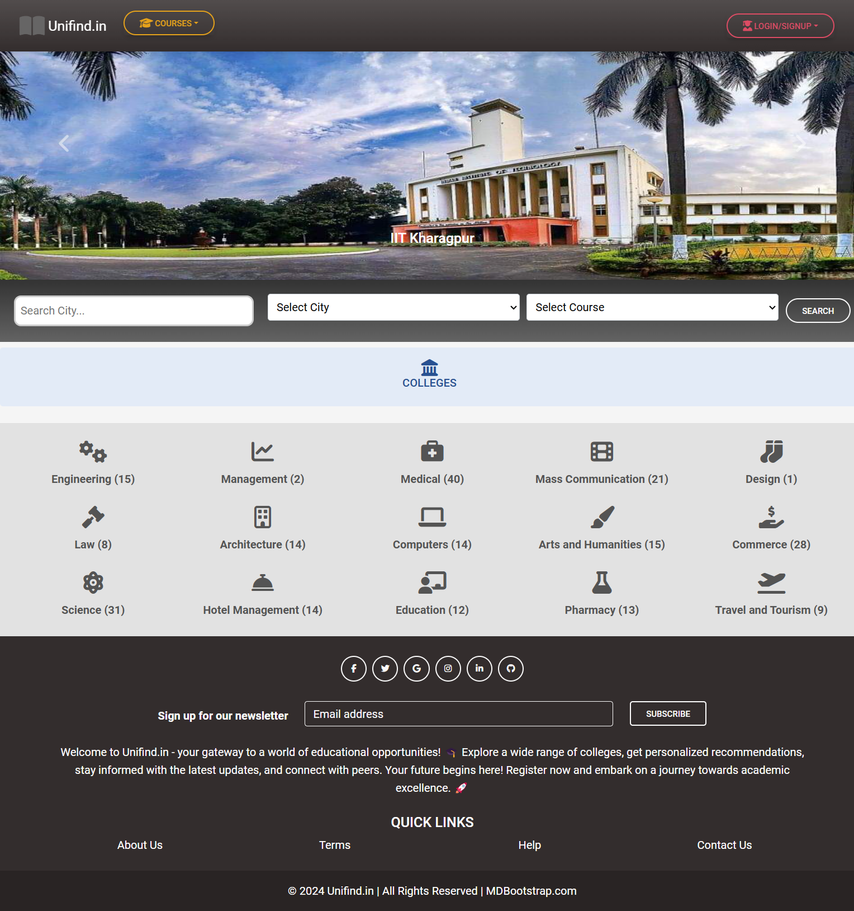

* **Student User Registration Page:**

This module helps us to register user. The contents are id, firstName, lastName, email, address, city, state, phone and password. After registration, the users informations are stored in the database.

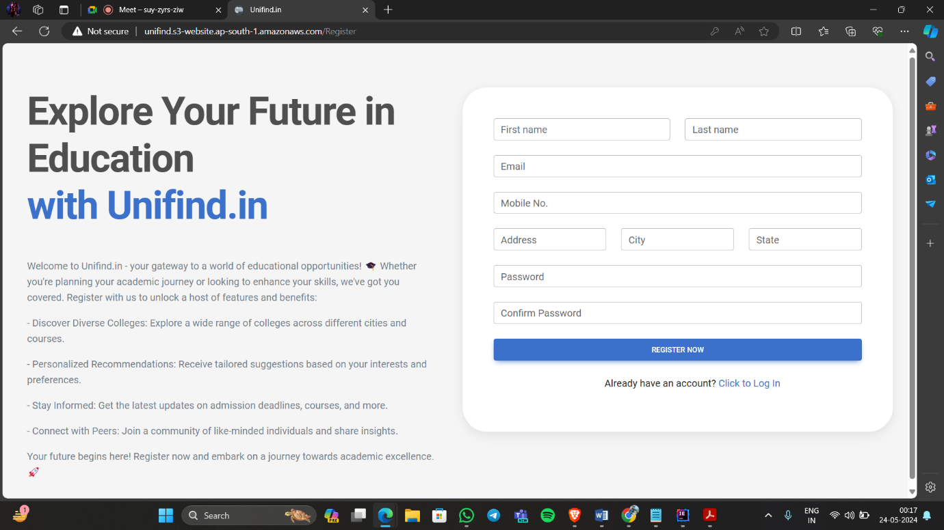

Code:

import React, { useState } from "react";

import Axios from "axios";

import { useNavigate } from "react-router-dom";

import {

MDBBtn,

MDBContainer,

MDBRow,

MDBCol,

MDBCard,

MDBCardBody,

MDBInput,

MDBIcon,

} from "mdb-react-ui-kit";

import "./StudentRegister.css";

function Register() {

const navigate = useNavigate();

const url = "http://3.110.19.137:8080/user/add";

const [data, setData] = useState({

firstName: "",

lastName: "",

address: "",

city: "",

state: "",

phone: "",

email: "",

password: "",

confirmPassword: "", // Add confirmPassword to the state });

const [errors, setErrors] = useState({});

function handle(e) {

const newData = { ...data };

newData[e.target.id] = e.target.value;

setData(newData);

setErrors((prevErrors) => ({

...prevErrors,

[e.target.id]: "", // Clear the error message when the user starts typing}));}

function validateForm() {

let valid = true;

const newErrors = {};

// Add your validation logic here

if (!data.firstName.trim()) {

newErrors.firstName = "*First name is required";

valid = false;}

if (!data.lastName.trim()) {

newErrors.lastName = "*Last name is required";

valid = false;}

if (!data.email.trim() || !/\S+@\S+\.\S+/.test(data.email.trim())) {

newErrors.email = "*Valid email address is required";

valid = false;}

if (!data.phone.trim()) {

newErrors.phone = "*Phone number is required";

valid = false;}

if (!/^\d{10}$/.test(data.phone.trim())) {

newErrors.phone = "*Phone number should be 10 digits";

valid = false;}

if (!data.address.trim()) {

newErrors.address = "*Address is required";

valid = false;}

if (!data.city.trim()) {

newErrors.city = "*City is required";

valid = false;}

if (!data.state.trim()) {

newErrors.state = "*State is required";

valid = false;}

if (!data.password.trim()) {

newErrors.password = "*Password is required";

valid = false;}

if (!/^.{8,}$/.test(data.password.trim())) {

newErrors.password = "*Password must be at least 8 characters";

valid = false;}

if (!data.confirmPassword.trim()) {

newErrors.confirmPassword = "*Confirm Your Password";

valid = false; }

if (data.password != data.confirmPassword) {

newErrors.confirmPassword = "*Password and Confirm Password not matched";

valid = false; }

setErrors(newErrors);

return valid;}

function submit(e) {

e.preventDefault();

if (validateForm()) {

Axios.post(url, {

firstName: data.firstName,

lastName: data.lastName,

address: data.address,

city: data.city,

state: data.state,

phone: data.phone,

email: data.email,

password: data.password,

isAdmin: false,

isCollegeUser: false,

}).then((res) => {

navigate("/Login");});}}

return (

<form onSubmit={(e) => submit(e)}>

<MDBContainer fluid className="p-4">

<MDBRow>

<MDBCol

md="6"

className="text-center text-md-start d-flex flex-column justify-content-center">

<h1 className="my-5 display-3 fw-bold ls-tight px-3">

Explore Your Future in Education <br />

<span className="text-primary">with Unifind.in</span>

</h1>

<div className="px">

<p className="px-3" style={{ color: "hsl(217, 10%, 50.8%)" }}>

Welcome to Unifind.in - your gateway to a world of educational

opportunities! 🎓 Whether you're planning your academic journey

or looking to enhance your skills, we've got you covered.

Register with us to unlock a host of features and benefits:

</p>

<p className="px-3" style={{ color: "hsl(217, 10%, 50.8%)" }}>

- Discover Diverse Colleges: Explore a wide range of colleges

across different cities and courses.

</p>

<p className="px-3" style={{ color: "hsl(217, 10%, 50.8%)" }}>

- Personalized Recommendations: Receive tailored suggestions

based on your interests and preferences.

</p>

<p className="px-3" style={{ color: "hsl(217, 10%, 50.8%)" }}>

- Stay Informed: Get the latest updates on admission deadlines,

courses, and more.

</p>

<p className="px-3" style={{ color: "hsl(217, 10%, 50.8%)" }}>

- Connect with Peers: Join a community of like-minded

individuals and share insights.

</p>

<p className="px-3" style={{ color: "hsl(217, 10%, 50.8%)" }}>

Your future begins here! Register now and embark on a journey

towards academic excellence. 🚀

</p>

</div>

</MDBCol>

<MDBCol md="6">

<MDBCard className="my-5">

<MDBCardBody className="p-5">

<MDBRow>

<MDBCol col="6">

{errors.firstName && (

<div className="text-danger">{errors.firstName}</div>)}

<MDBInput

wrapperClass="mb-4"

label="First name"

id="firstName"

type="text"

onChange={(e) => handle(e)}

value={data.firstName}/>

</MDBCol>

<MDBCol col="6">

{errors.lastName && (

<div className="text-danger">{errors.lastName}</div>)}

<MDBInput

wrapperClass="mb-4"

label="Last name"

id="lastName"

type="text"

onChange={(e) => handle(e)}

value={data.lastName}/>

</MDBCol>

</MDBRow>

{errors.email && (

<div className="text-danger">{errors.email}</div>)}

<MDBInput

wrapperClass="mb-4"

label="Email"

id="email"

type="email"

onChange={(e) => handle(e)}

value={data.email}/>

{errors.phone && (

<div className="text-danger">{errors.phone}</div>)}

<MDBInput

wrapperClass="mb-4"

label="Mobile No."

id="phone"

type="text"

onChange={(e) => handle(e)}

value={data.phone}/>

<MDBRow>

<MDBCol col="4">

{errors.address && (

<div className="text-danger">{errors.address}</div>)}

<MDBInput

wrapperClass="mb-4"

label="Address"

id="address"

type="text"

onChange={(e) => handle(e)}

value={data.address}/>

</MDBCol>

<MDBCol col="4">

{errors.city && (

<div className="text-danger">{errors.city}</div>)}

<MDBInput

wrapperClass="mb-4"

label="City"

id="city"

type="text"

onChange={(e) => handle(e)}

value={data.city}/>

</MDBCol>

<MDBCol col="4">

{errors.state && (

<div className="text-danger">{errors.state}</div>)}

<MDBInput

wrapperClass="mb-4"

label="State"

id="state"

type="text"

onChange={(e) => handle(e)}

value={data.state}/>

</MDBCol>

</MDBRow>

{errors.password && (

<div className="text-danger">{errors.password}</div>)}

<MDBInput

wrapperClass="mb-4"

label="Password"

id="password"

type="password"

onChange={(e) => handle(e)}

value={data.password}/>

{errors.confirmPassword && (

<div className="text-danger">{errors.confirmPassword}</div>)}

<MDBInput

wrapperClass="mb-4"

label="Confirm Password"

id="confirmPassword"

type="password"

onChange={(e) => handle(e)}

value={data.confirmPassword}/>

<MDBBtn

className="w-100 mb-4"

color="primary"

size="md"

type="submit"

value="Submit">

Register Now

</MDBBtn>

<div className="text-center">

<p className="ms-5">

Already have an account?{" "}

<a href="/Login" className="link-primary">

Click to Log In

</a>

</p>

</div>

</MDBCardBody>

</MDBCard>

</MDBCol>

</MDBRow>

</MDBContainer>

</form>);}

export default Register;

**Validation checks:**

function validateForm() {

let valid = true;

const newErrors = {};

// Add your validation logic here

if (!data.firstName.trim()) {

newErrors.firstName = "*First name is required";

valid = false;}

if (!data.lastName.trim()) {

newErrors.lastName = "*Last name is required";

valid = false;}

if (!data.email.trim() || !/\S+@\S+\.\S+/.test(data.email.trim())) {

newErrors.email = "*Valid email address is required";

valid = false;}

if (!data.phone.trim()) {

newErrors.phone = "*Phone number is required";

valid = false;}

if (!/^\d{10}$/.test(data.phone.trim())) {

newErrors.phone = "*Phone number should be 10 digits";

valid = false;}

if (!data.address.trim()) {

newErrors.address = "*Address is required";

valid = false;}

if (!data.city.trim()) {

newErrors.city = "*City is required";

valid = false;}

if (!data.state.trim()) {

newErrors.state = "*State is required";

valid = false;}

if (!data.password.trim()) {

newErrors.password = "*Password is required";

valid = false;}

if (!/^.{8,}$/.test(data.password.trim())) {

newErrors.password = "*Password must be at least 8 characters";

valid = false;}

if (!data.confirmPassword.trim()) {

newErrors.confirmPassword = "*Confirm Your Password";

valid = false; }

if (data.password != data.confirmPassword) {

newErrors.confirmPassword = "*Password and Confirm Password not matched";

valid = false; }

setErrors(newErrors);

return valid;}

**Explanation:**

Here, the data for every input fields is checked for not null and fields like email, phone, password are checked according to their regular expression or regex for email, according to their respective length of digits for phone number and passwords i.e., 10 digits for phone number and minimum 8 digits for passwords.

* **College User Registration Page:**

This module helps us to register college user. The contents are collegeName, affiliation, addres, state, city, certification, establishmentYear, firstName, lastName, phone, email, password etc. After registration, the college users informations are stored in the database.

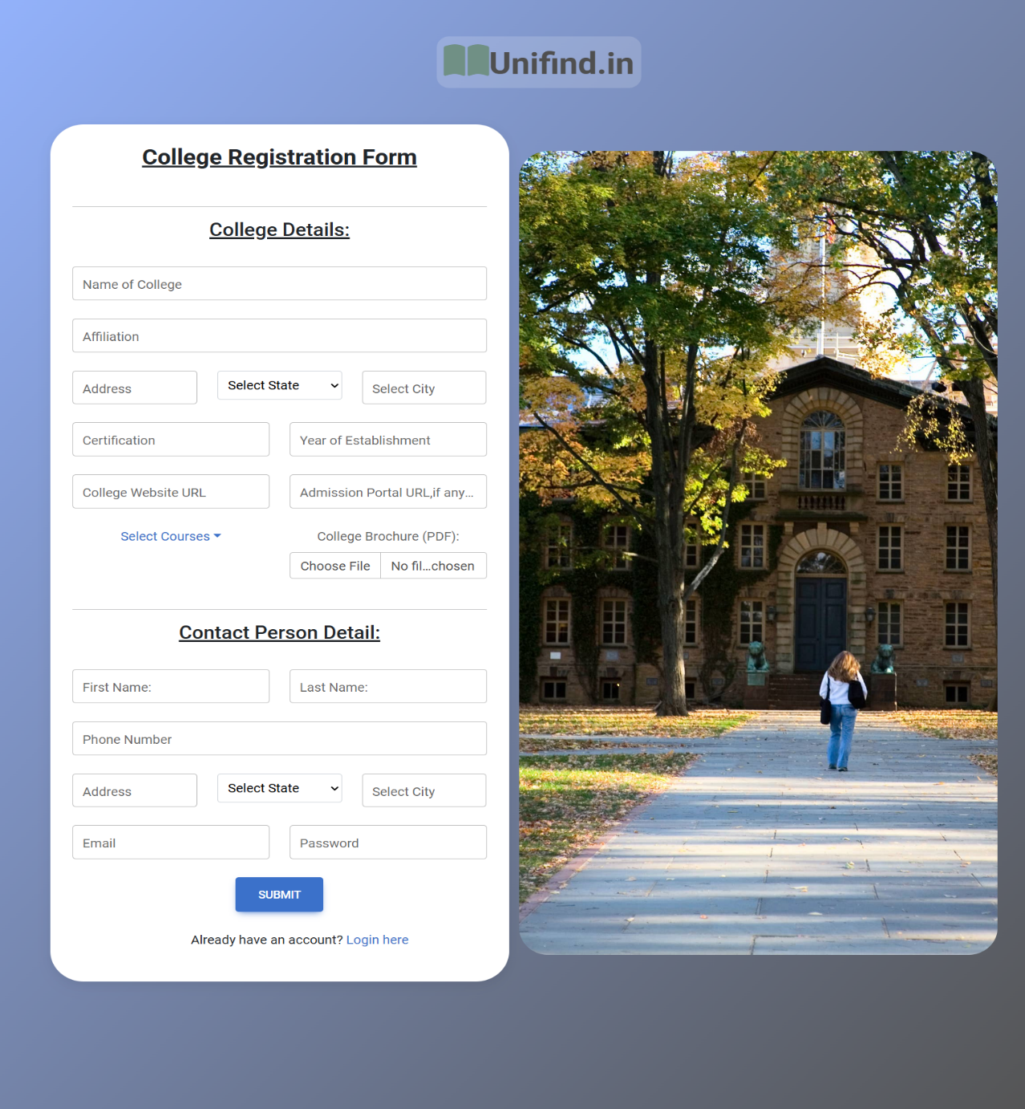

**Code:**

import React, { useState, useEffect } from "react";

import Axios from "axios";

import { useNavigate } from "react-router-dom";

import {

MDBBtn,

MDBContainer,

MDBCard,

MDBCardBody,

MDBRow,

MDBCol,

MDBDropdown,

MDBDropdownToggle,

MDBDropdownMenu,

MDBIcon,

MDBInput,

} from "mdb-react-ui-kit";

import "./CollegeRegister.css";

const CollegeRegister = () => {

const [collegeData, setCollegeData] = useState({

name: "",

firstName: "",

lastName: "",

phoneNumber: "",

address: "",

state: "",

city: "",

email: "",

password: "",

affiliation: "",

certification: "",

establishmentYear: "",

collegeCourses: [],

brochurefileUri: "",

filename: "",

collegeweb: "",

applyweb: "",

useraddress: "",

userstate: "",

usercity: "",});

const [course, setCourse] = useState([]);

const navigate = useNavigate();

useEffect(() => {

const fetchData = async () => {

try {

const response = await Axios.get(

"http://3.110.19.137:8080/courses/get");

setCourse(response.data.map((course) => course.course));

} catch (error) {

console.error("Error fetching courses:", error);}};

fetchData();}, []);

const [errors, setErrors] = useState({});

const states = [

"Andhra Pradesh",

"Arunachal Pradesh",

"Assam",

"Bihar",

"Chhattisgarh",

"Goa",

"Gujarat",

"Haryana",

"Himachal Pradesh",

"Jharkhand",

"Karnataka",

"Kerala",

"Madhya Pradesh",

"Maharashtra",

"Manipur",

"Meghalaya",

"Mizoram",

"Nagaland",

"Odisha",

"Punjab",

"Rajasthan",

"Sikkim",

"Tamil Nadu",

"Telangana",

"Tripura",

"Uttar Pradesh",

"Uttarakhand",

"West Bengal",

"Andaman and Nicobar Islands",

"Chandigarh",

"Dadra and Nagar Haveli and Daman and Diu",

"Delhi",

"Lakshadweep",

"Puducherry",];

const handleCourseChange = (index, value) => {

setCollegeData((prevData) => {

const updatedCourses = [...prevData.collegeCourses];

if (value != undefined) {

updatedCourses[index] = { id: value };}

return {

...prevData,

collegeCourses: updatedCourses,};});

setErrors((prevErrors) => ({

...prevErrors,

[`course${index}`]: "",

collegeCourses: "",}));};

const validateForm = () => {

let valid = true;

const newErrors = {};

if (!collegeData.name.trim()) {

newErrors.name = "*College name is required";

valid = false;}

if (!collegeData.firstName.trim()) {

newErrors.firstName = "*Contact person name is required";

valid = false;}

if (!collegeData.lastName.trim()) {

newErrors.lastName = "*Contact person name is required";

valid = false;}

if (

!collegeData.phoneNumber.trim() ||

!/^\d{10}$/.test(collegeData.phoneNumber.trim())) {

newErrors.phoneNumber = "*Valid 10-digit phone number is required";

valid = false;}

if (!collegeData.state.trim()) {

newErrors.state = "*State is required";

valid = false;}

if (!collegeData.city.trim()) {

newErrors.city = "*City is required";

valid = false;}

if (

!collegeData.email.trim() ||

!/\S+@\S+\.\S+/.test(collegeData.email.trim())) {

newErrors.email = "*Valid email is required";

valid = false;}

if (!collegeData.affiliation.trim()) {

newErrors.affiliation = "*Affiliation is required";

valid = false;}

if (!collegeData.certification.trim()) {

newErrors.certification = "*Certification is required";

valid = false;}

if (

!collegeData.establishmentYear.trim() ||

!/^\d{4}$/.test(collegeData.establishmentYear.trim())) {

newErrors.establishmentYear = "*Valid 4-digit year is required";

valid = false;}

if (!collegeData.collegeCourses.length) {

newErrors.collegeCourses = "*At least one course is required";

valid = false;

} else {

collegeData.collegeCourses.forEach((course, index) => {

if (!course || !course.id) {

newErrors[`course${index}`] = `*Course ${index + 1} is required`;

valid = false;}});}

setErrors(newErrors);

return valid;};

const [file, setFile] = useState(null);

const handleFileChange = (event) => {

setFile(event.target.files[0]);};

useEffect(() => {

if (

collegeData.brochurefileUri !== "" &&

collegeData.filename !== "" &&

validateForm()) {

Axios.post(`http://3.110.19.137:8080/College/add`, collegeData)

.then((res) => {

Axios.post("http://3.110.19.137:8080/user/add", {

firstName: collegeData.firstName,

lastName: collegeData.lastName,

address: collegeData.useraddress,

city: collegeData.usercity,

state: collegeData.userstate,

phone: collegeData.phoneNumber,

email: collegeData.email,

password: collegeData.password,

isCollegeUser: true,})

.then((res) => {

navigate("/Login");})

.catch((error) => {

console.error("Error submitting user form:", error);});})

.catch((error) => {

console.error("Error submitting college form:", error);});}

}, [collegeData, navigate]);

const handleSubmit = (e) => {

e.preventDefault();

if (!file) {

alert("Please select a brochure file");

return;}

const formData = new FormData();

formData.append("file", file);

Axios.put("http://3.110.19.137:8080/files", formData, {

headers: {

"Content-Type": "multipart/form-data",},})

.then((res) => {

console.log("File uploaded successfully:", res.data);

console.log(res.data.fileDownloadUrl);

setCollegeData((prevData) => ({

...prevData,

brochurefileUri: res.data.fileDownloadUrl,

filename: res.data.filename,}));})

.catch((error) => {

console.error("Error uploading file:", error);});};

const handleChange = (e) => {

const { id, value } = e.target;

setCollegeData((prevData) => ({

...prevData,

[id]: value,}));

setErrors((prevErrors) => ({

...prevErrors,

[id]: "",}));};

return (

<div className="form-body">

<div

className="d-flex flex-row ps-5 pt-5"

style={{ justifyContent: "center" }}>

<div className="icon">

<MDBIcon

fas

icon="book-open"

size="3x"

style={{ color: "#709085" }}/>

<span className="h1 fw-bold mb-0">Unifind.in</span>

</div>

</div>

<MDBContainer fluid>

<MDBRow className="justify-content-center align-items-center p-5">

<MDBCol md="6">

<MDBCard>

<MDBCardBody className="px-4">

<h3

className="fw-bold mb-4 pb-2 pb-md-0 mb-md-5 "

style={{ textDecoration: "underline" }}>

College Registration Form

</h3>

<form onSubmit={handleSubmit}>

<hr />

<h4>

<u>College Details:</u>

</h4>

<br />

<MDBRow>

<MDBCol md="">

<MDBInput

wrapperClass="mb-4"

label="Name of College"

size="lg"

id="name"

type="text"

onChange={handleChange}

value={collegeData.name}/>

{errors.name && (

<div className="text-danger">{errors.name}</div>)}

</MDBCol>

</MDBRow>

<MDBRow>

<MDBCol md="">

<MDBInput

wrapperClass="mb-4"

label="Affiliation"

size="lg"

id="affiliation"

type="text"

onChange={handleChange}

value={collegeData.affiliation}/>

{errors.affiliation && (

<div className="text-danger">{errors.affiliation}</div>)}

</MDBCol>

</MDBRow>

<MDBRow>

<MDBCol md="4">

<MDBInput

wrapperClass="mb-4"

label="Address"

size="lg"

id="address"

type="text"

onChange={handleChange}

value={collegeData.address}/>

{errors.address && (

<div className="text-danger">{errors.address}</div>)}

</MDBCol>

<MDBCol md="4">

<select

className="custom-select"

id="state"

onChange={handleChange}

value={collegeData.state}>

<option value="">Select State</option>

{states.map((state, index) => (

<option key={index} value={state}>

{state}

</option>))}

</select>

{errors.state && (

<div className="text-danger">{errors.state}</div>)}

</MDBCol>

<MDBCol md="4">

<MDBInput

wrapperClass="mb-4"

label="Select City"

size="lg"

id="city"

type="text"

onChange={handleChange}

value={collegeData.city}/>

{errors.city && (

<div className="text-danger">{errors.city}</div>)}

</MDBCol>

</MDBRow>

<MDBRow>

<MDBCol md="6">

<MDBInput

wrapperClass="mb-4"

label="Certification"

size="lg"

id="certification"

type="text"

onChange={handleChange}

value={collegeData.certification}/>

{errors.certification && (

<div className="text-danger">

{errors.certification}

</div>)}

</MDBCol>

<MDBCol md="6">

<MDBInput

wrapperClass="mb-4"

label="Year of Establishment"

size="lg"

id="establishmentYear"

type="text"

onChange={handleChange}

value={collegeData.establishmentYear}/>

{errors.establishmentYear && (

<div className="text-danger">

{errors.establishmentYear}

</div>)}

</MDBCol>

</MDBRow>

<MDBRow>

<MDBCol md="6">

<MDBInput

wrapperClass="mb-4"

label="College Website URL"

size="lg"

id="collegeweb"

type="text"

onChange={handleChange}

value={collegeData.collegeweb}/>

{errors.collegeweb && (

<div className="text-danger">{errors.collegeweb}</div>)}

</MDBCol>

<MDBCol md="6">

<MDBInput

wrapperClass="mb-4"

label="Admission Portal URL,if any or else add the same URL"

size="lg"

id="applyweb"

type="text"

onChange={handleChange}

value={collegeData.applyweb}/>

{errors.applyweb && (

<div className="text-danger">{errors.applyweb}</div>)}

</MDBCol>

</MDBRow>

<MDBRow>

<MDBCol md="">

<MDBDropdown>

<MDBDropdownToggle tag="a">

Select Courses

</MDBDropdownToggle>

<MDBDropdownMenu

style={{ overflow: "auto", maxHeight: "160px" }}>

{course.map((_, index) => (

<div

key={index}

className="custom-control custom-checkbox">

<input

type="checkbox"

className="custom-control-input"

id={`courseCheckbox${index}`}

checked={

collegeData.collegeCourses[index]?.id !==

undefined}

onChange={() =>

handleCourseChange(

index,

collegeData.collegeCourses[index]?.id

? undefined

: index + 1)}/>

<label

className="custom-control-label"

htmlFor={`courseCheckbox${index}`}>

{course[index]}

</label>

{errors.collegeCourses &&

errors.collegeCourses[index] && (

<div className="text-danger">

{errors.collegeCourses[index]}

</div>)}

</div>))}

</MDBDropdownMenu>

</MDBDropdown>

</MDBCol>

<MDBCol md="6">

<label className="form-label" htmlFor="brochureFile">

College Brochure (PDF):

</label>

<input

className="form-control mb-4"

type="file"

id="brochureFile"

onChange={handleFileChange}

accept=".pdf"/>

</MDBCol>

<MDBCol md="6">

{errors.collegeCourses && (

<div className="text-danger">

{errors.collegeCourses}

</div>)}

</MDBCol>

</MDBRow>

<hr />

<h4>

<u>Contact Person Detail:</u>

</h4>

<br />

<MDBRow>

<MDBCol md="6">

<MDBInput

wrapperClass="mb-4"

label="First Name:"

size="lg"

id="firstName"

type="text"

onChange={handleChange}

value={collegeData.firstName}/>

{errors.contactName && (

<div className="text-danger">{errors.firstName}</div>)}

</MDBCol>

<MDBCol md="6">

<MDBInput

wrapperClass="mb-4"

label="Last Name:"

size="lg"

id="lastName"

type="text"

onChange={handleChange}

value={collegeData.lastName}/>

{errors.lastName && (

<div className="text-danger">{errors.lastName}</div>)}

</MDBCol>

<MDBCol md="12">

<MDBInput

wrapperClass="mb-4"

label="Phone Number"

size="lg"

id="phoneNumber"

type="text"

onChange={handleChange}

value={collegeData.phoneNumber}/>

{errors.phoneNumber && (

<div className="text-danger">{errors.phoneNumber}</div>)}

</MDBCol>

</MDBRow>

<MDBRow>

<MDBCol md="4">

<MDBInput

wrapperClass="mb-4"

label="Address"

size="lg"

id="useraddress"

type="text"

onChange={handleChange}

value={collegeData.useraddress}/>

{errors.address && (

<div className="text-danger">{errors.useraddress}</div>)}

</MDBCol>

<MDBCol md="4">

<select

className="custom-select"

id="userstate"

onChange={handleChange}

value={collegeData.userstate}>

<option value="">Select State</option>

{states.map((state, index) => (

<option key={index} value={state}>

{state}

</option>))}

</select>

{errors.userstate && (

<div className="text-danger">{errors.userstate}</div>)}

</MDBCol>

<MDBCol md="4">

<MDBInput

wrapperClass="mb-4"

label="Select City"

size="lg"

id="usercity"

type="text"

onChange={handleChange}

value={collegeData.usercity}/>

{errors.usercity && (

<div className="text-danger">{errors.usercity}</div>)}

</MDBCol>

</MDBRow>

<MDBRow>

<MDBCol md="6">

<MDBInput

wrapperClass="mb-4"

label="Email"

size="lg"

id="email"

type="email"

onChange={handleChange}

value={collegeData.email}/>

{errors.email && (

<div className="text-danger">{errors.email}</div>)}

</MDBCol>

<MDBCol md="6">

<MDBInput

wrapperClass="mb-4"

label="Password"

size="lg"

id="password"

type="password"

onChange={handleChange}

value={collegeData.password}/>

{errors.password && (

<div className="text-danger">{errors.password}</div>)}

</MDBCol>

</MDBRow>

<MDBBtn className="mb-4" size="lg" type="submit">

Submit

</MDBBtn>

</form>

<p className="ms-5">

Already have an account?{" "}

<a href="/Collegelogin" className="link-primary">

Login here

</a>

</p>

</MDBCardBody>

</MDBCard>

</MDBCol>

<MDBCol md="6" className="d-none d-sm-block px-0">

<img

src="https://img.buzzfeed.com/buzzfeed-static/complex/images/depg0oqo1inie9ifcg3d/most-beautiful-college-campuses-title.jpg?output-format=jpg&output-quality=auto"

width={486}

height={1060}

alt="Login image"

className="w-100"

style={{

borderRadius: "35px",

objectFit: "cover",

objectPosition: "center",}}/>

</MDBCol>

</MDBRow>

</MDBContainer>

</div>);};

export default CollegeRegister;

**Validation Check:**

const validateForm = () => {

let valid = true;

const newErrors = {};

if (!collegeData.name.trim()) {

newErrors.name = "*College name is required";

valid = false;}

if (!collegeData.firstName.trim()) {

newErrors.firstName = "*Contact person name is required";

valid = false;}

if (!collegeData.lastName.trim()) {

newErrors.lastName = "*Contact person name is required";

valid = false;}

if (

!collegeData.phoneNumber.trim() ||

!/^\d{10}$/.test(collegeData.phoneNumber.trim())) {

newErrors.phoneNumber = "*Valid 10-digit phone number is required";

valid = false;}

if (!collegeData.state.trim()) {

newErrors.state = "*State is required";

valid = false;}

if (!collegeData.city.trim()) {

newErrors.city = "*City is required";

valid = false;}

if (

!collegeData.email.trim() ||

!/\S+@\S+\.\S+/.test(collegeData.email.trim())) {

newErrors.email = "*Valid email is required";

valid = false;}

if (!collegeData.affiliation.trim()) {

newErrors.affiliation = "*Affiliation is required";

valid = false;}

if (!collegeData.certification.trim()) {

newErrors.certification = "*Certification is required";

valid = false;}

if (

!collegeData.establishmentYear.trim() ||

!/^\d{4}$/.test(collegeData.establishmentYear.trim())) {

newErrors.establishmentYear = "*Valid 4-digit year is required";

valid = false;}

if (!collegeData.collegeCourses.length) {

newErrors.collegeCourses = "*At least one course is required";

valid = false;

} else {

collegeData.collegeCourses.forEach((course, index) => {

if (!course || !course.id) {

newErrors[`course${index}`] = `*Course ${index + 1} is required`;

valid = false;}});}

setErrors(newErrors);

return valid;};

**Explanation:**

Here, the data for every input fields is checked for not null and fields like email, phone, password are checked according to their regular expression or regex for email, according to their respective length of digits for phone number and passwords i.e., 10 digits for phone number and minimum 8 digits for passwords.

* **Student User/College User Login Page:**

This module helps us to login the user in the website. The contents are email and password. After login, the user can search the college details and also apply for colleges.

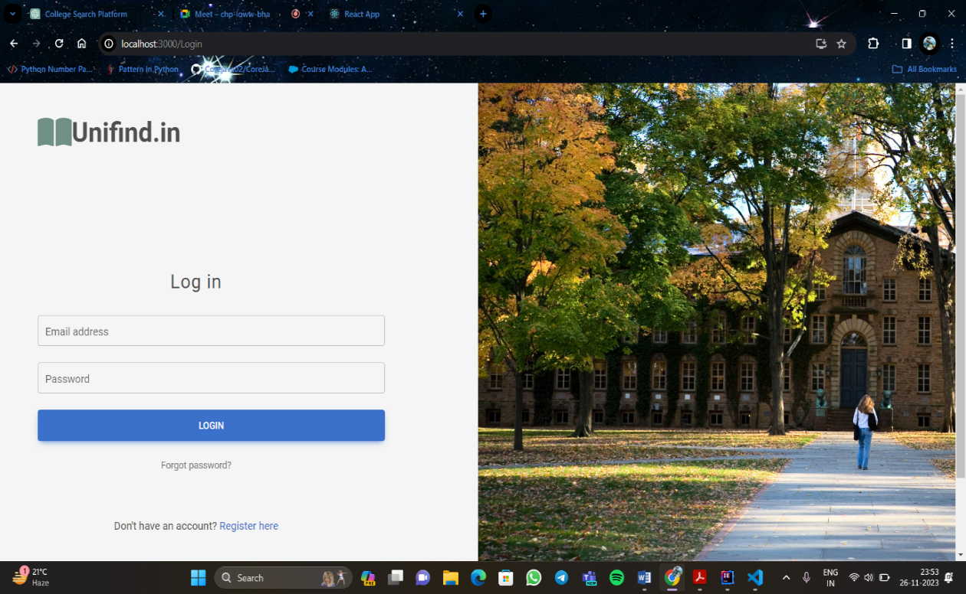

**Frontend:**

import React, { useState } from "react";

import Axios from "axios";

import { useNavigate } from "react-router-dom";

import {

MDBBtn,

MDBContainer,

MDBRow,

MDBCol,

MDBIcon,

MDBInput,

} from "mdb-react-ui-kit";

import "./StudentLogin.css";

function Login() {

const navigate = useNavigate();

const url = "http://3.110.19.137:8080/login";

const [data, setData] = useState({

userName: "",

password: "",});

function handle(e) {

const newData = { ...data };

newData[e.target.id] = e.target.value;

setData(newData);}

function submit(e) {

e.preventDefault();

Axios.post(url, {

userName: data.userName,

password: data.password,

}).then((res) => {

if (res.data == true) {

sessionStorage.setItem("email", data.userName);

navigate("/");} else {

alert("Email doesn't exist or the password is incorrect...");}});}

return (<>

<form onSubmit={(e) => submit(e)}>

<MDBContainer fluid>

<MDBRow>

<MDBCol sm="6">

<div className="d-flex flex-row ps-5 pt-5">

<MDBIcon

fas

icon="book-open"

size="3x"

style={{ color: "#709085" }}/>

<span className="h1 fw-bold mb-0">Unifind.in</span>

</div>

<div className="d-flex flex-column justify-content-center h-custom-2 w-75 pt-4">

<h3

className="fw-large mb-3 ps-5 pb-3"

style={{ letterSpacing: "1px" }}>

Log in to Continue

</h3>

<MDBInput

wrapperClass="mb-4 mx-5 w-100"

label="Email address"

id="userName"

type="email"

size="lg"

onChange={(e) => handle(e)}

value={data.userName}

required/>

<MDBInput

wrapperClass="mb-4 mx-5 w-100"

label="Password"

id="password"

type="password"

size="lg"

onChange={(e) => handle(e)}

value={data.password}

required/>

<MDBBtn

className="mb-4 px-5 mx-5 w-100"

color="primary"

size="lg">

Login

</MDBBtn>

<p className="small mb-5 pb-lg-3 ms-5">

<a className="text-muted" href="#!">

Forgot password?

</a>

</p>

<p className="ms-5">

Don't have an account?{" "}

<a href="/Register" className="link-primary">

Register here for Students

</a>

<br />

If you want to join as College User!{" "}

<a href="/College-register" className="link-primary">

Register here

</a>

</p>

</div>

</MDBCol>

<MDBCol sm="6" className="d-none d-sm-block px-0">

<img

src="https://img.buzzfeed.com/buzzfeed-static/complex/images/depg0oqo1inie9ifcg3d/most-beautiful-college-campuses-title.jpg?output-format=jpg&output-quality=auto"

width={486}

height={729}

alt="Login image"

className="w-100"

style={{ objectFit: "cover", objectPosition: "left" }}/>

</MDBCol>

</MDBRow>

</MDBContainer>

</form>

</>);}

export default Login;

**Backend:**

package com.collegesearch.collegesearch.service;

import com.collegesearch.collegesearch.Model.LoginModel;

import com.collegesearch.collegesearch.Util.SecurityManager;

import com.collegesearch.collegesearch.entity.UserEntity;

import com.collegesearch.collegesearch.entity.CollegeEntity;

import com.collegesearch.collegesearch.repository.CollegeRepository;

import com.collegesearch.collegesearch.repository.UserRepository;

import lombok.AllArgsConstructor;

import org.springframework.stereotype.Service;

import java.util.Optional;

@Service

@AllArgsConstructor

public class LoginService {

UserService userService;

UserRepository userRepository;

SecurityManager securityManager;

CollegeRepository collegeRepository;

public Boolean checkLogin(LoginModel loginModel) {

Optional<UserEntity> userOptional = userRepository.findByEmail(loginModel.getUserName()).stream().findFirst();

if (userOptional.isPresent()) {

UserEntity user = userOptional.get();

return securityManager.checkPassword(loginModel.getPassword(), user.getPassword());

} else {

throw new IllegalStateException("User not found for email: " + loginModel.getUserName());}}}

* **Custom Search Module:**

This module helps us to search for the colleges. The user can select the college according to the specifications given by the user.

The specifications are location and course. They can update search for colleges by changing the specifications.



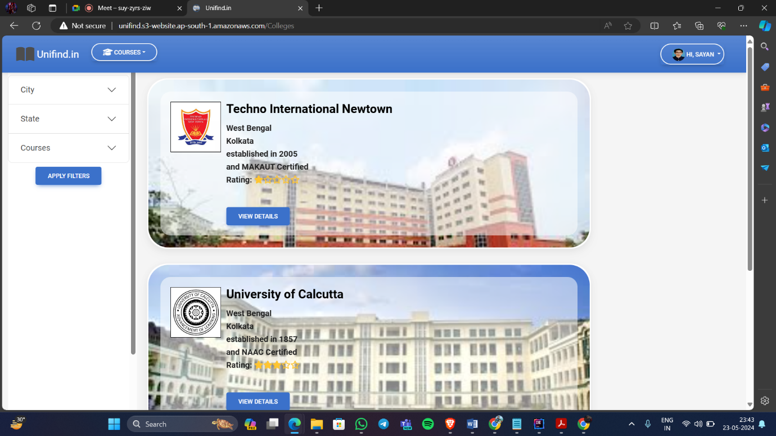

* **College Profile:**

In this module, we can see the college profile like college name, location, affiliation etc. Users can access comprehensive details about specific colleges.

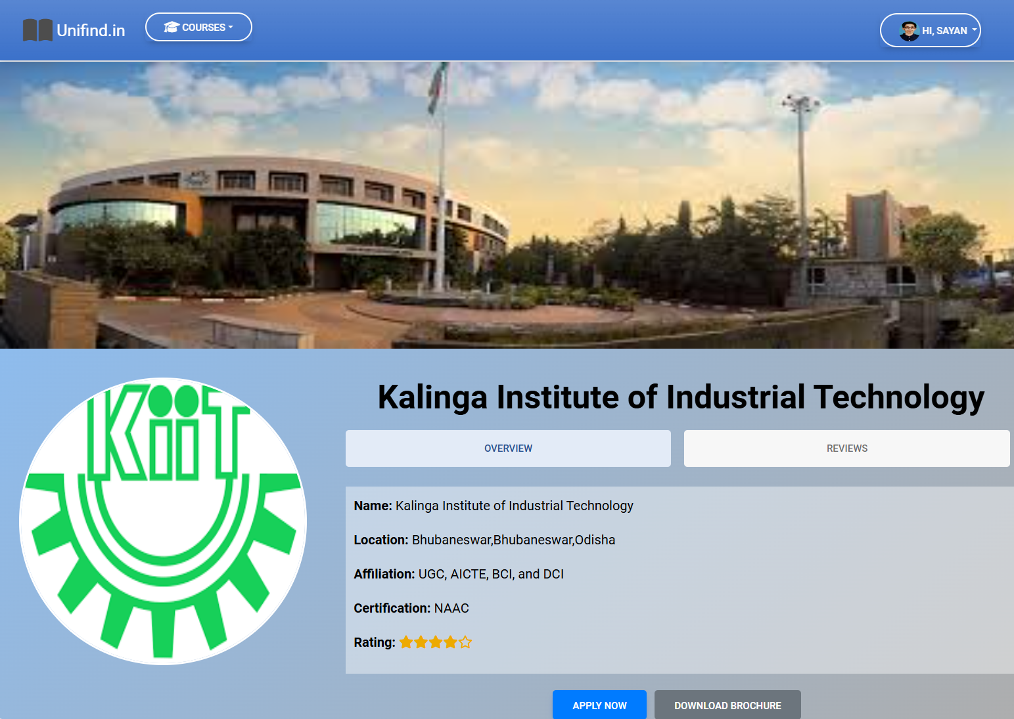

* **Admin Dashboard:**

In this module, the admin or administrator can add, update, delete or view the user and college details of the college search website. It also shows the total number of users and colleges in the database.

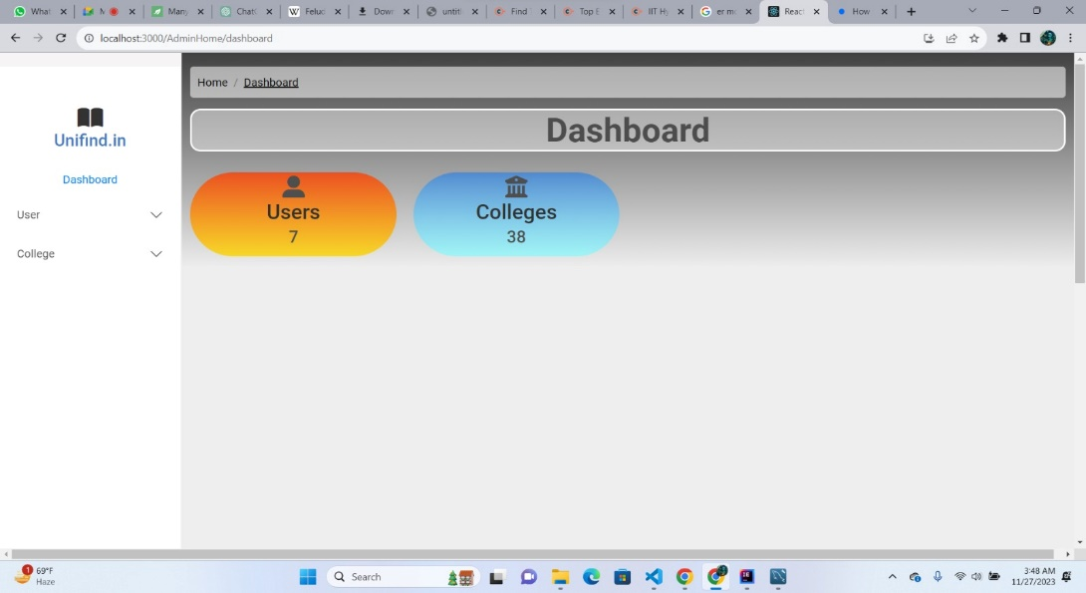

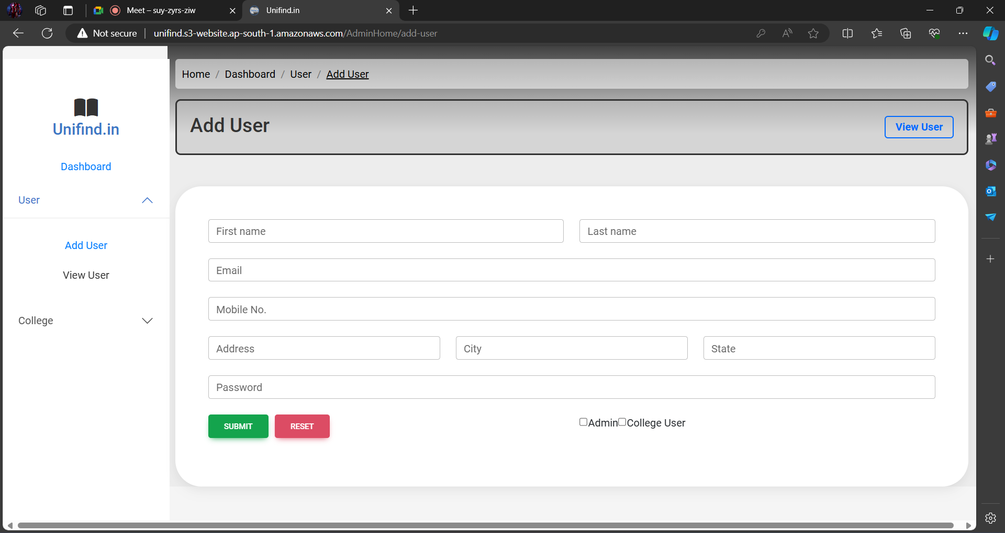

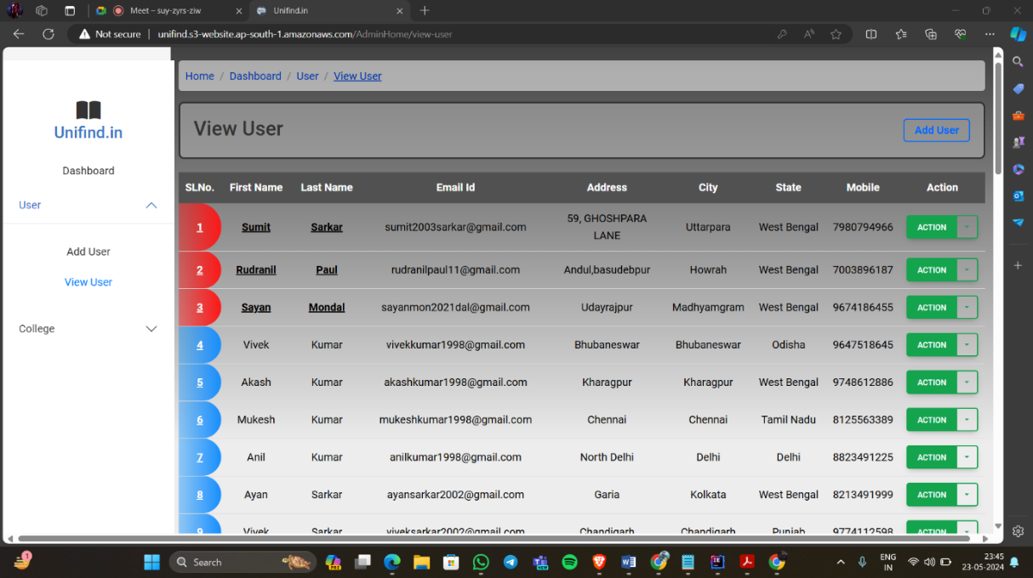

College User Admin

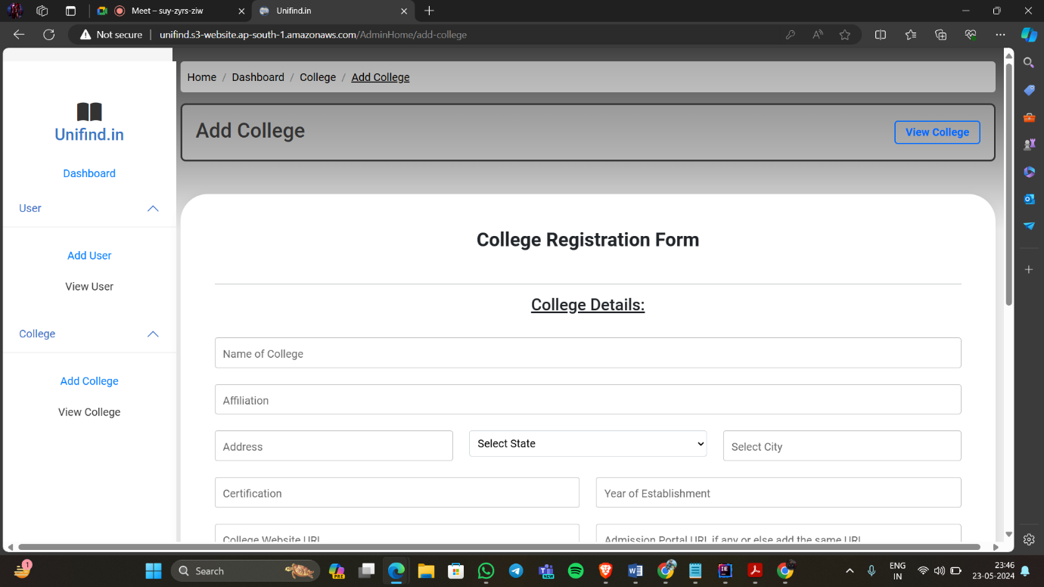

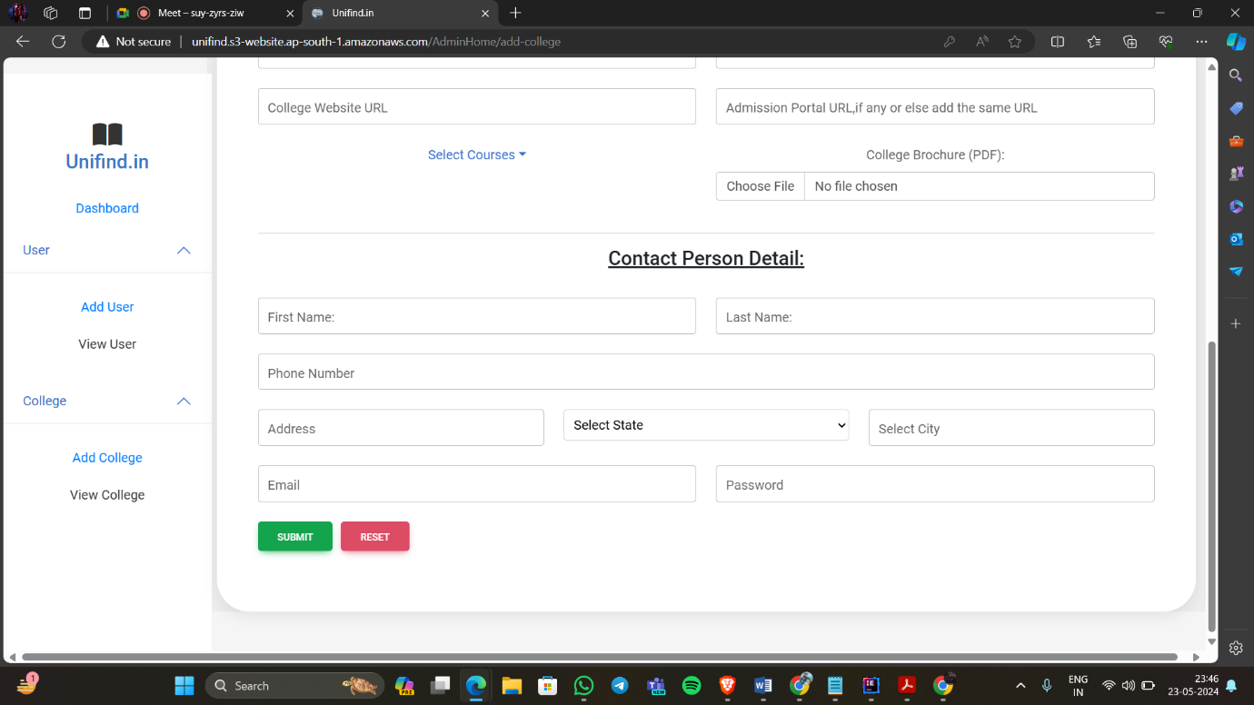

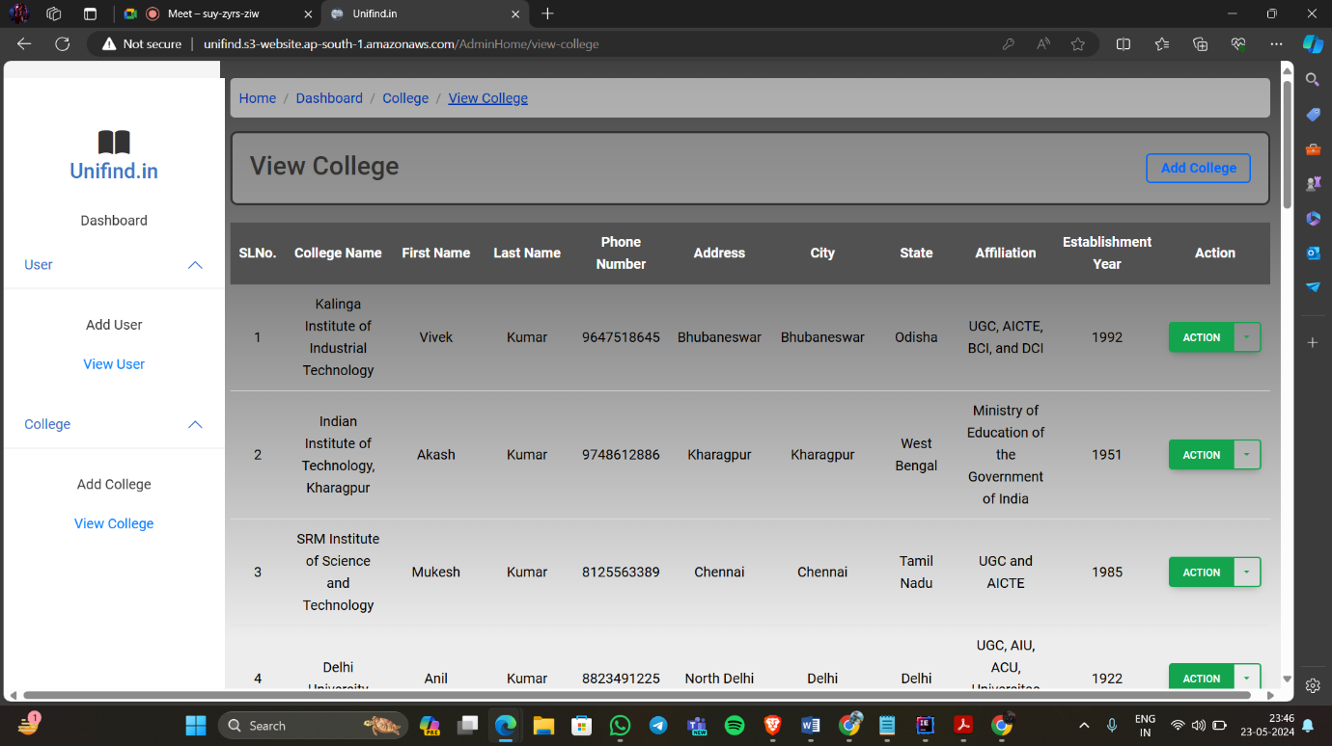

1. **Testing:**

Testing is a process of executing a program with the interest of finding an error. A good test is one that has high probability of finding the yet undiscovered error. Testing should systematically uncover different classes of errors in a minimum amount of time with a minimum amount of efforts. Two classes of inputs are provided to test the process

1. A software configuration that includes a software requirement specification, a design specification and source code.
2. A software configuration that includes a test plan and procedure, any testing tool and test cases and their expected results.
   1. **Testing Techniques and Testing Strategies:**

Testing Techniques and Testing Strategies Used are ----------

**Testing Techniques: ---**

**Unit Testing -----**

* Ensures individual components function correctly.
* Uses tools like JUnit and Mocha for automated testing.

**Integration Testing -----**

* Verifies that integrated modules work together.
* Ensures data flow between modules is accurate.

**System Testing -----**

* Validates the complete and integrated software.
* Tests functional and non-functional requirements.

**Performance Testing -----**

* Assesses system performance under load.
* Includes stress testing, load testing, and endurance testing.

**Testing Strategies: ---**

**Test-Driven Development (TDD):** Write tests before code to ensure that the system meets requirements from the start.

**Behavior-Driven Development (BDD):** Write test cases in a natural language that describes the expected behavior.

**Automated Testing:** Uses automation tools for efficiency and coverage.

**Manual Testing:** Essential for exploratory, usability, and ad-hoc testing.

* 1. **Testing Plan Used:**

**Testing Phases: ---**

**Preparation Phase:**

* Define the scope, objectives, and resources.
* Prepare the test environment and data.

**Design Phase:**

* Write and review detailed test cases.

**Execution Phase:**

* Execute unit tests, integration tests, system tests, and regression tests.
* Log and track defects.

**Closure Phase:**

* Compile test results and prepare test reports.
* Conduct a test closure meeting to discuss outcomes and improvements.

**Test Environments:**

* Development Environment: For unit and integration testing.
* Staging Environment: For system and acceptance testing.
* Production Environment: For final validation and monitoring.
  1. **Test reports for Unit Test Cases and System Test Cases:**

**Unit Test Report: ---**

Test Case ID: U001

Description: Test user registration with valid data.

Input Data: Valid username, email, and password.

Expected Result: User registration successful.

Actual Result: User registration successful.

Status: Pass

**System Test Report: ---**

Test Case ID: S001

Description: Test end-to-end workflow of college search.

Preconditions: User is logged in.

Steps:

Navigate to search page.

Enter search criteria.

Submit search.

Expected Result: Search results displayed as per criteria.

Actual Result: Search results displayed as per criteria.

Status: Pass

* 1. **Debugging and Code improvement:**

**Debugging Process: ---**

**Identify the Issue -----**

* Use logs and error messages to pinpoint the problem.
* Reproduce the issue for better understanding.

**Analyze the Code -----**

* Review relevant code sections.
* Use debugging tools to inspect variable values and code flow.

**Fix the Issue -----**

* Implement necessary changes.
* Ensure the fix does not introduce new issues.

**Test the Fix -----**

* Run tests to verify the fix.
* Validate that the issue is resolved and no new issues are introduced.

**Deploy the Fix -----**

* Deploy changes to the appropriate environment.
* Monitor the system for unexpected behavior.

**Code Improvement Techniques: ---**

**Code Refactoring -----**

* Improve code structure and readability.
* Use design patterns and best practices.

**Optimization -----**

* Enhance performance by optimizing algorithms and data structures.

**Code Reviews -----**

* Conduct regular reviews to identify potential issues and improvements.

**Automated Testing -----**

* Increase test coverage with automated tests.
* Use CI tools to run tests automatically on code changes.

1. **System Security Measures:**

Ensuring the security of a college search and review website involves implementing multiple layers of defense to protect user data, maintain the integrity of the system, and safeguard against potential threats.

* 1. **Security Measures: ---**

1. **Authentication and Authorization -----**

* Implement secure user authentication mechanisms.
* Use role-based access control to restrict access to sensitive data.

1. **Data Encryption -----**

* Encrypt sensitive data at rest and in transit.
* Use industry-standard encryption algorithms like AES and TLS.

1. **Input Validation -----**

* Validate all user inputs to prevent SQL injection, XSS, and other attacks.
* Use prepared statements and parameterized queries.

1. **Session Management -----**

* Implement secure session management practices.
* Use HTTP-only and secure cookies.
  1. **Database/Data Security: ---**

**Database Security Measures:**

1. **Access Control -----**

* Restrict database access to authorized users.
* Use least privilege principle for database accounts.

1. **Data Masking -----**

* Mask sensitive data to prevent unauthorized access.

1. **Backup and Recovery -----**

* Implement regular data backup and recovery procedures.
* Ensure backups are securely stored and encrypted.

1. **Monitoring and Logging -----**

* Monitor database activities for suspicious behavior.
* Implement logging to track access and changes to data.

**Creation of User Profiles and Access Rights :**

**User Profiles and Access Rights: ---**

1. **Define Roles -----**

* Create roles based on different levels of access (e.g., admin, user, reviewer).
* Assign appropriate permissions to each role.

1. **Profile Management -----**

* Allow users to create and manage their profiles.
* Ensure secure password management and profile updates.

1. **Access Control -----**

* Implement role-based access control for different sections of the website.
* Use middleware to check user permissions before accessing resources.

1. **Process logic of Module (Flow Chart):**

* **Flow Chart of The College Search Website:**

yes

Show all the User and College Details

If User type Admin

Database

Admin

no

Do not see any Details

login

College Search System

Register User

User

login

Login User

Search College

Apply College

1. **Cost Estimation of the Project along with Cost Estimation Model:**

**Development Costs: ---**

1. **Personnel:**

Developers and Designers: Utilize students and volunteers to work on the project as part of their coursework or internships, incurring no cost.

Estimated Cost: INR 0

2. **Tools and Software:**

Development Tools: Use open-source tools such as React.js, Spring Boot, and MySQL, which are free to use.

Software Licenses: Rely on free or educational versions where available.

Estimated Cost: INR 0

**Infrastructure Costs: ---**

1. **Hosting:**

Utilize the free tiers of cloud services such as AWS Educate, Google Cloud Free Tier, or the GitHub Student Developer Pack, which offer free credits for students.

Estimated Cost: INR 600

2. **Database:**

Use the free tier of cloud-based database services or host a small-scale database on a local server.

Estimated Cost: INR 0

**Maintenance and Support Costs: ---**

1. **Ongoing Maintenance:**

Managed by the students as part of their learning and project requirements.

Estimated Cost: INR 0

2. **Customer Support:**

Handle support through free channels like email and social media managed by the project team.

Estimated Cost: INR 0

**Equipment and Miscellaneous Costs: ---**

1. **Development Equipment:**

Allocate funds for any necessary hardware or peripherals required for development that students might not already have (e.g., external hard drives, extra RAM).

Estimated Cost: INR 45,000

**2. Internet and Utilities:**

Cover the cost of internet access and other utilities if not already provided.

Estimated Cost: INR 1,500

**Contingency Fund: ---**

To cover any unexpected expenses such as minor software tools, emergency hosting needs, or additional hardware.

Estimated Cost: INR 2,500

Total Estimated Cost

Overall Total: INR 49,600

**Detailed Allocation: ---**

1. Development Equipment (INR 45,000)

Purchase necessary hardware or peripherals to aid in the development process.

2. Hosting (INR 600)

Utilize the free tiers of cloud services such as AWS Educate, Google Cloud Free Tier, or the GitHub Student Developer Pack, which offer free credits for students.

3. Internet and Utilities (INR 1,500)

Ensure reliable internet access and cover any utility costs that might arise.

4. Contingency Fund (INR 2,500)

Set aside for unexpected costs and emergencies, such as minor software tools, additional hardware, or unforeseen expenses.

1. **Future Scope of Enhancement:**

Here are several potential avenues for enhancing a college search website developed in a minor project-----

1. **Admission Predictor:**

* Develop an admission predictor tool based on historical admission data, test scores, GPA, extracurricular activities, etc.
* Provide users with an estimate of their chances of admission to specific colleges based on their profile information.

1. **Exam System:**

* Create a practice exam system for standardized tests like SAT, ACT, GRE, etc., allowing students to gauge their readiness.
* Offer detailed feedback on performance, areas for improvement, and access to study resources.
* Provide personalized study plans or recommendations based on exam results to aid in preparation.

By considering these avenues for enhancement, the college search website can evolve into a more comprehensive and sophisticated platform, providing a richer user experience and further empowering students in their quest for higher education.

1. **Conclusion:**

In conclusion, the development of the college search website for this minor project has been an enlightening journey toward creating a platform aimed at revolutionizing the higher education search process. Throughout this endeavour, key insights and learnings have emerged, underscoring the significance of such a tool in guiding students toward their academic aspirations.

This project has demonstrated the vital role of technology in simplifying the intricate task of finding the ideal college fit. The platform's user-centric design, intuitive interface, and robust functionalities have strived to empower users in making informed decisions about their educational futures.

The collaborative effort involved in conceptualizing, designing, and implementing this website underscores the importance of teamwork and interdisciplinary skills in realizing a comprehensive solution. From frontend development utilizing React.js to backend integration with Spring Boot and MySQL, each technological component contributed to a cohesive and responsive user experience.

Moreover, this project highlighted the importance of adaptability and responsiveness to user needs. Incorporating features like personalized profiling, extensive database searches, and interactive mapping aimed to cater to diverse preferences and streamline the exploration process.

While this minor project encapsulates a foundational prototype, it also signifies the potential for further enhancements and refinements. Future iterations could include expanded functionalities, deeper integration with external APIs for enriched data, and enhanced accessibility measures to ensure inclusivity.

In essence, this college search website stands as a testament to the fusion of technology and education, offering a glimpse into the possibilities of transforming the higher education landscape. As it culminates, this project reflects a commitment to facilitating students' journeys toward finding their perfect educational pathway, emphasizing the profound impact of technology in shaping the future of academia.

1. **Bibliography:**

In the making of report, I got a lot of help from websites. The sources are----------

* <https://www.youtube.com/>
* <https://www.w3schools.com/REACT>/
* <https://www.geeksforgeeks.org/nodejs/>
* <https://www.javatpoint.com/spring-boot-tutorial>
* <https://www.tutorialspoint.com/spring_boot/index.htm>

1. **Glossary:**

**A**

Accreditation: The process by which a college or university is evaluated and recognized as meeting certain predetermined standards of education.

Admission Requirements: The criteria set by colleges that students must meet to be considered for acceptance.

Alumni: Graduates or former students of a specific college or university.

**B**

Bachelor’s Degree: An undergraduate academic degree awarded by colleges and universities upon completion of a course of study lasting three to seven years (depending on institution and academic discipline).

Benchmarking: Comparing one's processes and performance metrics to industry bests and best practices from other institutions.

**C**

Campus: The grounds and buildings of a university or college.

College Review: An evaluation or assessment of a college, typically written by students, alumni, or educational experts.

Course Catalog: A comprehensive listing of all courses offered by a college or university.

**D**

Data Privacy: Protecting the personal data of users from unauthorized access and ensuring confidentiality.

Degree Program: A course of study offered by a college or university that leads to a degree.

**E**

Enrollment: The process of registering or entering a student into a college or university.

Extracurricular Activities: Non-academic activities (e.g., sports, clubs) that can contribute to a student’s college experience and resume.

**F**

Financial Aid: Funding that assists students in covering their college expenses. This can include scholarships, grants, and loans.

Freshman: A student in their first year of college or university.

**G**

Grade Point Average (GPA): A numerical representation of a student's average performance across all their classes.

**H**

Housing: Accommodation provided by colleges for students, often including dormitories or student apartments.

**I**

Internship: A period of work experience offered by an organization for a limited period of time, often to students.

**J**

Junior: A student in their third year of college or university.

**L**

Lecture: A method of teaching in colleges where the instructor delivers a presentation on a particular subject to a large group of students.

**M**

Major: The primary focus of study for a college student.

Minor: A secondary focus of study for a college student, requiring fewer courses than a major.

**P**

Prerequisite: A course or requirement that a student must complete before being allowed to enroll in a more advanced course.

**R**

Registrar: The college official responsible for maintaining student records and managing course registrations.

**S**

Scholarship: Financial aid awarded to students based on various criteria, usually academic merit or other achievements.

Senior: A student in their fourth year of college or university.

**T**

Transcript: An official record of a student's academic performance and progress.

**U**

Undergraduate: A student who is pursuing a bachelor's degree.

**V**

Vocational Training: Education that prepares individuals for specific trades, crafts, and careers at various levels.

**W**

Work-Study Program: A federal student aid program that provides part-time employment while you are enrolled in school to help pay your education expenses.

**THANK YOU**